• ^{,w};
PLUS!
lanuary 2006
More Biometrics from IDausau Greg Perry and Rmsec Exploring One-UJay Cyliners Locksmith Business Tips and More!
*********AUTO**SCH 3-DIGIT 303
Breck H. Camp CML POBox47070 Atlanta GA 30362-0070
Ml.II II..II....I.III...II...I...I
I I.ll
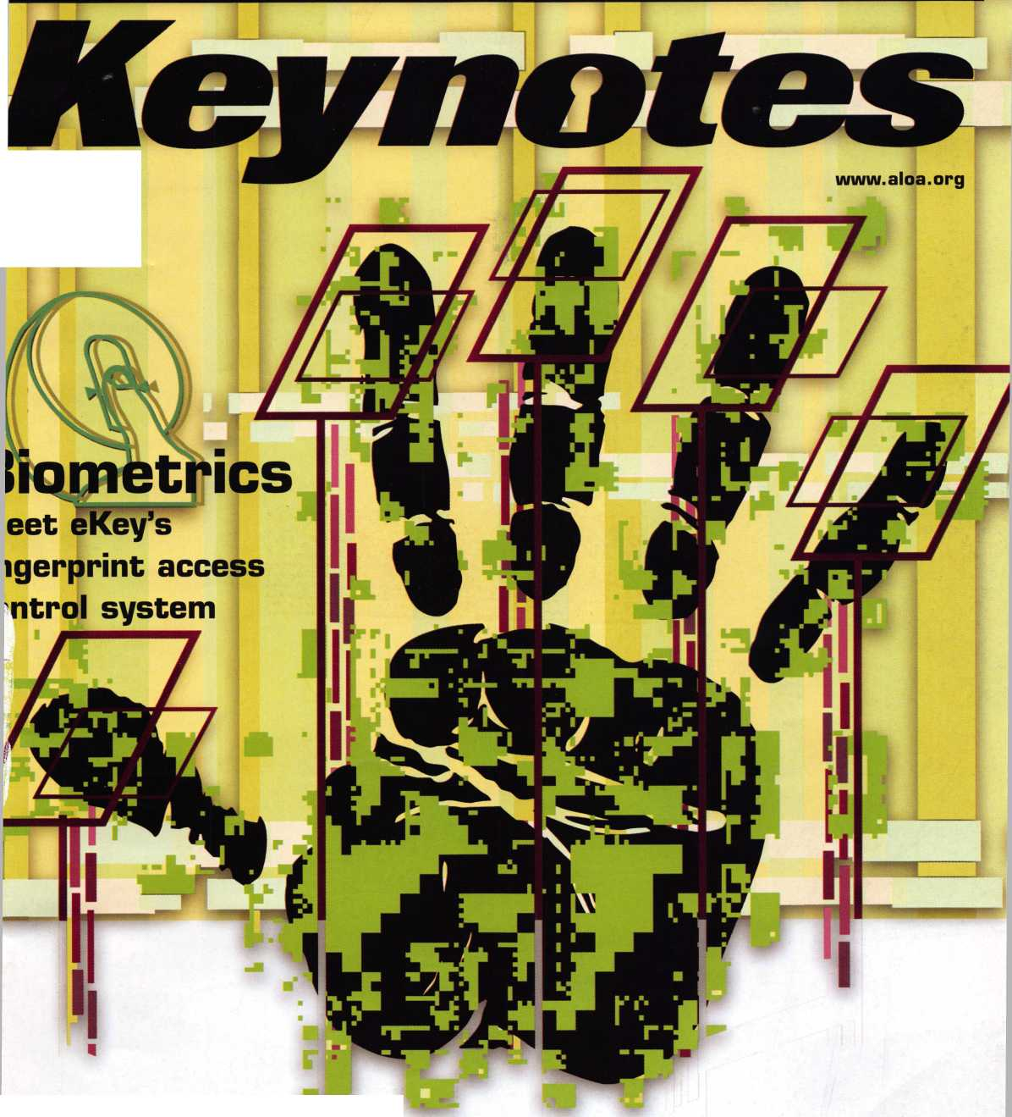

You're in good hands.
^{l}°cksh,
Subject to availability and qualified . Company, Bridgewater, N J, The " Cuj
ions. Allstate Insurance Company;'^orAustate Indemnity Company, Northbrook, IL. Allstate County Mutual Insurance Company, Irving, TX. Allstate New Jersey Insurance sped Hands" service mark and "Our Stand" is a service mark of Allstate Insurance Company. ©2005 Allstate Insurance Company, Northbrook, IL.
OUR STAND
1-800-859-0247
CALL NOW TO LOCATE YOUR NEARBY ALLSTATE AGENT.
IT’S QUITE POSSIBLY YOUR MOST

TRUSTED SIDEKICK
Keep it in Good Hands® with Allstate.
As a small business owner, there are few things you quick certificates of insurance, ID cards, assistance
rely on more than your vehicle to keep you going. with the claims process, and more. All from one of
Your local Allstate agent can help protect it and the most widely recognized names in the business,
your small business with services you need including Are you in Good Hands®?
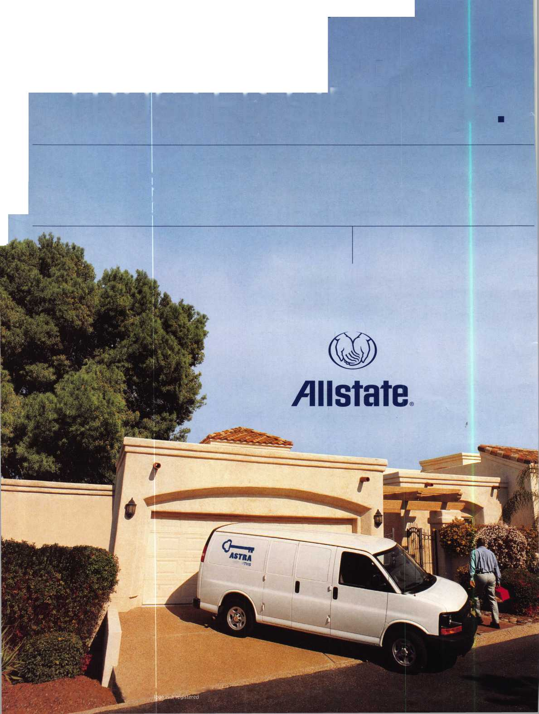

A Name You Know
As a business owner, you know the importance of a
good name. Your name is your reputation. Your name
stands for all that you offer in products and services.
It’s a symbol of who you are. So, we thought you
might like to know that Allstate, the name you know
for insuring your personal vehicle and your home,
also offers a business auto policy to help protect vehi-
cles used in your locksmith business.
The following are coverages typically included in
our business auto policy that might be important to
you as a business owner:
Business Auto Liability coverage
- Higher limits up to $2,000,000 per occur-
rence.
- Protects you if you are legally responsible
for injuries and damages arising out of
the ownership, maintenance, or use of
business vehicles.
- Cost is based on several factors, including
garage location, type and use of vehicle,
and the violation and accident activity of
your drivers.
- Additional Insured coverage may be
required when you contract with govern-
mental agencies or bid on local
commercial jobs.
- Generally not available on a personal auto
policy.
- Usually is no charge to add an insured to
a Commercial Auto policy.
Hired Auto coverage
- Provides liability coverage for those
vehicles you rent, hire or borrow for
business use.
- The premium for hired auto liability
coverage is based on the estimated
annual rental cost.
- Tools and Special Equipment
- Provides protection to permanently
attached equipment on your vehicle.
- You will need to let your agent know the
value of the equipment to include in the
cost of the vehicle.
You’re good at your business. Your insurance com-
pany should be the same way.
Contact an Allstate agent to discuss your business
auto insurance needs. To be referred to an agent,
please call 800.859.0247 or email
abis0@allstate.com.
Subject to availability and qualifications. Insurance coverage
is subject to policy terms.
Allstate Insurance Company
Allstate Indemnity Company
Northbrook, IL
Allstate County Mutual Insurance Company
Irving, TX
Allstate New Jersey Insurance Company
Bridgewater, NJ
allstate.com
© 2005 Allstate Insurance Company, Northbrook, IL
BETTER
THAN EVER.
This Hawkeye® Borescope
includes all of the latest upgrades for safe and vault professionals: Optics that deliver images that rival German scopes. A new mirror technology that resists scratches from insulation, asbestos, and burrs. And a mirror protection sleeve to ward off dust.
Plus the option of the
GRAND KIT with a fully
configured 7” and 17”
scope in one case. Or the
economy minded LE model.
The red eyecup tells you
that you have the scope
made specifically for safe
and vault professionals.
Available from Gradient Lens resellers to the safe and vault industry only.
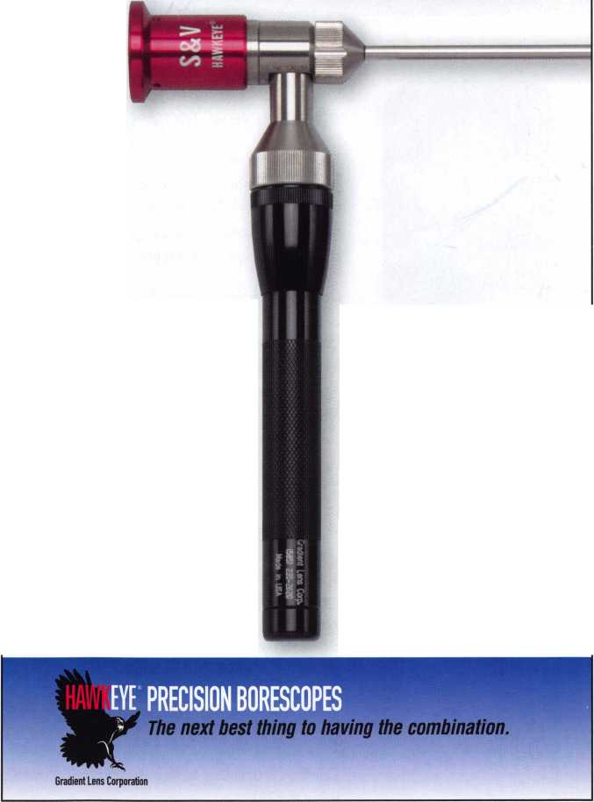
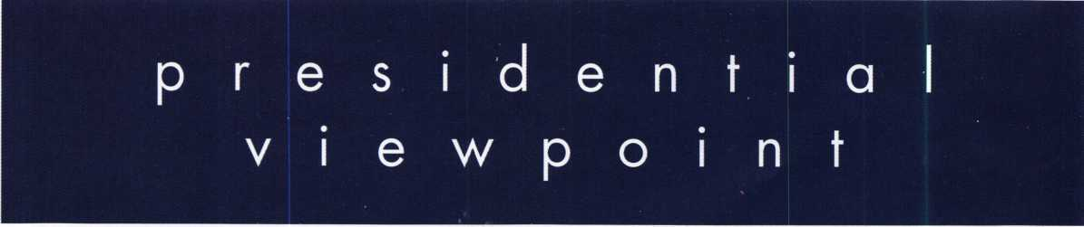
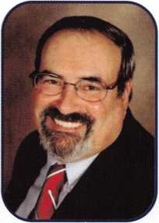
Dear Members,
Happy New Year!
Two thousand six, a new year, a fresh start! It is important at this time of year to reflect on the past and to learn from our personal histories. Equally imperative, or even more so, is to set goals and resolve to follow through. Make sound, well thought-out resolutions. A good goal is to become more involved with our fellow man and to make this world a better place. How does an individual in the security field fit into the grand scheme of things? Make a personal inventory and then...
Do well, what you do best. Treat your customers with the respect and honesty they deserve. Become active in your local association. Run for an office; work on a committee. Get your local association on the world stage; become an advocate for ALOA affiliation. Groups from around the globe are reaching out to ALOA for information, guidance and leadership. Be a leader; run as a candidate for an ALOA office. Learn; take a class or better yet, teach a class. Devote time to family and friends; that's the "stuff" of which a good life is made. Most importantly, take care of yourself. It is only when you are a healthy, happy, whole person, can you reach out to others.
Last month I had the pleasure of attending several holiday functions. The Greater Philadelphia Locksmiths' Association had a wonderful dinner-dance. The North Jersey Locksmiths' Association held a great gathering at which my wife and I were treated royally. There, I met many enthusiastic members with lots of energy and great ideas. The Central Pennsylvania Locksmiths' Association had a family-style smorgasbord dinner. Don Shiles was the guest speaker. Don spoke about his tour in Iraq. He emphasized that regardless of what is reported in the news media, our troops are appreciated and they are making the world a better place. His views were very up lifting. Of course, each association had plenty of prizes and surprises. Each party was different, but fellowship, excitement and exchange of views and new ideas abounded. This was the social side of associations at their best!
I know it's almost six months away, but, while we're making resolutions, let's include attending ALOA's 50th in Las Vegas. It's going to be a milestone in our association's history.
Our Staff is planning the biggest and best convention yet. Don't miss out, especially on that chance to drive home the T-Bird!
Best of health, wealth and happiness for the New Year. Have a glorious 2006!
Take 'er easy!
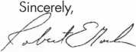
Robert E. Mock
Keynotes • January 2006

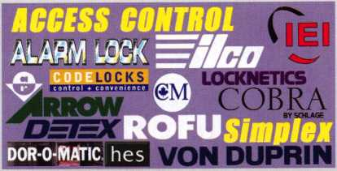

AUTOMOTIVE Jet
C»' Ullll 11 LOCKCRAFT g)
©ASP HAM
DETERMINATOR MAJOR (fet.non
♦
PRO-
STRATTEC
Wedgec& ‘
Why Do
Locksmiths
Everywhere Buy
Supplies at
CAL-ROYAL
I.HMM
jadison
£/2iJ
LCN
MONARCH
hlcumkhm
SARGENT
SCHLAGE
VON DUPRIN
nu-wimn
iSSSeSSSL
roots
<*£ DEHin A1
AABUi
©ASP
AVENGER
ffiriStfCffi
H.L.FIake?
$ Extremely Competitive
E/Z Free Freight Minimums
LOCKCRAFT VA
OCK IECHNOLOGY
MAJOR
PRD-LOK
Peterson
www. tnriRKt. cum
- Order 24 hours a day
- Updated Every Business Day
- Extra Discount for Web Orders
- Personalized Inventory Lists
LOG ON TO...

www. Hirlake, con
QlQ«tfc *Q90g
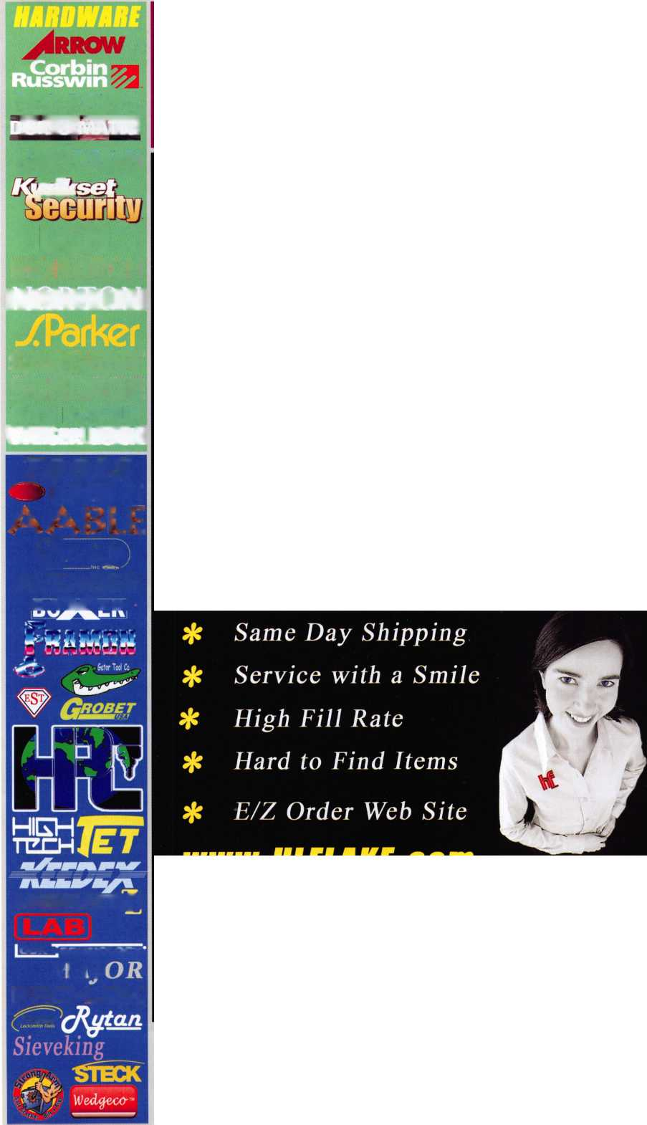

f
a
t
u
e
BIOMETRICS 2006
Biometrics: Fingerprint Access Control
We take a close look at the many exciting advancements and advantages that come with ekey biometric systems.
Biometrics: Aspirus Wausau Hospital
Find out what happened when a major Wisconsin hospital took it's security system to a biometric level.
One-Way Cylinders
Eric Costley gives us insight into the little known world of one-way cylinders and how you may gain a customer for life with a bit of know how.
by Eric Costley, CPL
Out of Time
Not enough hours in your day? Find out how you can take a proactive approach to time management.
by Claire L. Cohen, CML
The BF and the Convertible Gun Safes
Read about what Amsec has to offer in their recently introduced new line of gun safes, the BF series.
by Greg Perry, CML, CPS
New Tools
Check out how the new cost-effetive bench-top marker software called FHandy Andy can work for you.
r
AD INDEX
Allstate | Inside Front Cover
Gradient Lens |  | 1
HL Flake |  | 3
Safetech 2006 |  | 7
IR |  | 13
ALOA 2006 |  | 19
Ultralift |  | 21
Hinge Doctor |  | 23
CCL |  | 25
KABA llco |  | 27
TLA |  | 29
Strattec |  | 31
Dugmore and Duncan |  | 33
SafeData |  | 34
FKI | ; | 41
A&B Safe |  | 42
PBP |  | 42
Keedex | • | 42
Turn 10 |  | 42
Clearstar |  | 42
ALOA Bookstore | : | 43
MLANJ |  | 44
CompX | Inside Back Cover
Hickok |  | Back Cover
L |  |  | A
Departments
Presidential Execui
^{View}P°^{int} ² Appl.
five 5
cants 6
Calendar 8
Core 9
Classified 36
Associate Members 38
Legislative 40
Visit our NEW website at
www.aloa.org

executive
Volume 52, Issue 1
Additional contact information for the ALOA Board and most Keynotes authors is
available through "Locksmith Search'" on the ALOA Web site- www.aloa.org or by
contacting the ALOA office at 3500 Easy Street; Dallas, TX 75247; (800)532-2562;
FAX (214)819-9736; e-mail aloa@aloa.org.
Editor
Betty Henderson betty@aloa.org
Advertising Sales
Kim Hammond voice: 817-645-6778
Fax: 817-645-7599 e-mail: adsales@aloa.org
Executive Director
Charles W. Gibson, Jr., CAE charlie@aloa.org
Associate Executive Director
David Lowell, CML, CMST david@aloa.org
Convention & Meetings Manager
Jo Anne Mims joanne@aloa.org
Operations/Membership Manager
Mary May mary@aloa.org
Director of Creative Services
Betty Henderson betty@aloa.org
IT Operations Manager
Greg Jackson greg@aloa.org
Comptroller Kathy J. Romo
Membership Coordinator Shelly Jett
Convention & Meetings Assistant Karen Lyons
PRP/Education Coordinator Mayra Ocon
Mail Room Coordinator Kevin Wesley
Creative Media Specialist Margarita Garza
Accounting Coordinator Joyce Nixon
Executive Assistant Sue Langford
Assistant Education Manager Bob Stafford
Legislation Manager Tim McMullen
Contributors
Jerome Andrews, CML
Paul Chandler, CRL
Claire Cohen, CML
Brian Costley, CML, CMST
Eric Costley, CRL
Ray D'Adamo, CML Billy Edwards, CML Dan Graffeo, CRL,CMST Jim Hancock, CPL Jeff Nunberg, CML, CMST
Randy Simpson, CML, CPP Robert Stafford, CML Dave Thielen, CML Greg Perry, CML,CPS
Tom Seroogy
Charles Stephenson, CPS
Dennis Watanabe, CML, CMST
Mission Statement: The Associated Locksmiths of America, Inc. is dedicated to enhancing the professionalism, education and ethics among locksmiths and those in related sectors of the physical security industry. With approximately 10,000 members in the United States, Canada and the freeworld, ALOA is poised to help members obtain the knowledge, the strength, and the confidence to perform their role in the physical security field with pride and dignity. But it is only through active involvement and participation that ALOA can fully achieve its potential—and can help members to achieve theirs.
Policies: Keynotes® is the official publication of the Associated Locksmiths of America, Inc. (ALOA). Keynotes® acts as a moderator without approving, disapproving, or guaranteeing the validity or accuracy of any data, claim, or opinion appearing under a byline or obtained or quoted from an acknowledged source. The opinions expressed by the authors do not necessarily reflect the official views of ALOA. Also, appearance of advertisements and new products or service information does not constitute an endorsement of products or services featured by the Association. The Association does not accept responsibility for the inaccuracy of any data, claim, or opinion appearing in this publication, due to typographical errors on the part of the authors, Association staff or its agents.
Editor's Note: This publication is designed to provide accurate and authoritative information in regard to the subject matter covered. It is provided and disseminated with the understanding that the publisher is not engaged in rendering legal or other professional services. If legal advice and other expert assistance is required, the services of a competent professional should be sought.
Authors' Payment: Payment for eligible submissions to Keynotes will be based on the following criteria: topic, time spent and past contributions. Authors who regularly submit to Keynotes® are generally paid a higher rate. The latter is especially true of authors who write to fit specific editorial needs and submit said copy by Keynotes® deadlines. As a general guideline: Average payment for a 750 word, business or light' technical article would be $200. Payment for a 1500 word article involving significantly higher time and research efforts would be $400.
Payment will not be offered for articles submitted by ALOA employees or members of the ALOA Board of Directors (unless material is of a technical nature), nor for articles submitted by a company that promote that company's products or services. ALOA reserves the right not to pay for articles submitted by an individual(s) that promote a particular company's products or services.
Disclaimer: The Associated Locksmiths of America, Inc., (ALOA), reserves the right to refuse any article for any reason. Additionally, ALOA reserves the right to edit, amend or modify any article submitted for publication in order to preserve technical accuracy, clarity, fairness or grammatical correctness. ALOA will make the best efforts to notify the author of any changes. The extent of ALOA's liability for any article or information contained therein will be a notice of correction or retraction in the next possible issue.
Keynotes® (ISSN 0277 0792) is published monthly except for the combined June/July issue by The Associated Locksmiths of America, Inc., 3500 Easy St., Dallas, TX 75247-6416. Telephone: (214) 819-9733; FAX (214) 819-9736; e-mail aloa@aloa.org. Subscription rates for members—$15.00 per year. Periodical class postage paid at Dallas, Texas. POSTMASTER: Send address changes to: Keynotes, 3500 Easy St., Dallas, TX 75247-6416. © Copyright 2003, All rights reserved. No part of the contents may be reproduced or reprinted in any form without prior written permission of the publisher.
President
Robert Mock
(856) 863-0710
president@aloa. org
Secretary
John Soderland, CML, CMST
(414) 327-5625
Directors/ Northeast
Peter Sarailian, CRL
(201)944-7547
ned t rector@a!oa. org
Vernon Kelley, CPL
- 771-3126 nedirector@aloa.org
Directors, Southeast
Tom Gillingham, Jr., CML, CPS
(615) 264-0747
sedirector@aloa.org
Ken Kupferman, CML
(813) 961-5784
sed i rector@a loa. org
Director, North Central
William Smith, RL (920)893-5282 Guy Spinello, RL (815) 394-1000 ncd irector@aloa. org
Director, South Central
CD Lipscomb, CML, CPS
(903) 874-3522
scdirector@aloa.org
Directors, Southwest
Gordon R. Racine, CML
(719} 384-4707
swdirector@aloa .org
Julie McCluney, CRL
[714) 636-5652
swdi rector@aloa .org
Director, Northwest
Jim Jeffries, CPS
(877) 241-6978
nwd irector@aloa .org
Director, European
Hans Mejlshede, CML
(453) 539-3939
eurdirector@aloa.org
Director, Asian
Joe J. Lee, CRL
(215) 289-2404
asiand i rector@aloa. org
Director, Associate
Paul M. Justen
(612) 238-4646
asdirectOf@aloa.org
Trustees
trustees@aloa.org
Randy Simpson, CML
(281) 2405959
John J. Greenan, CML, CPS
(773) 486.2030
William Young, CML, CPS
- 647-5042
Past Presidents
2003-2005 William Young, CML, CPS
2001-2003 Randy Simpson, CML
1999-2001 John Greenan, CML, CPS
1997-1999 Dallas C. Brooks
1995-1997 David Lowell, CML, CMST
1993-1995 Breck Camp, CML
1991-1993 Henry Printz, CML
1989-1991 Evelyn Wersonick, CML, CPS
1987-1989 Leonard Passarello, CPL
1985-1987 Joe Jackman, CML
1983-1985 Stanley Haney, CPL
1981-1983 Louis LaGreco, CPL
1979-1981 John Kerr, RL
1977-1979 Clifford Cox, CML
1974-1977 Charles Hetheringfon
1972-1974 Gene Laughridge
1970-1972 William Dutcher, RL
1968-1970 Constant Maffey, RL
1966-1968 Harold Edelstein, RL
1964-1966 William Meacham
1962-1964 Robert Rackliffe, CPL
1960-1962 Edwin Toepfer, RL
1956-1960 Ernest Johannesen
Keynotes • January 2006

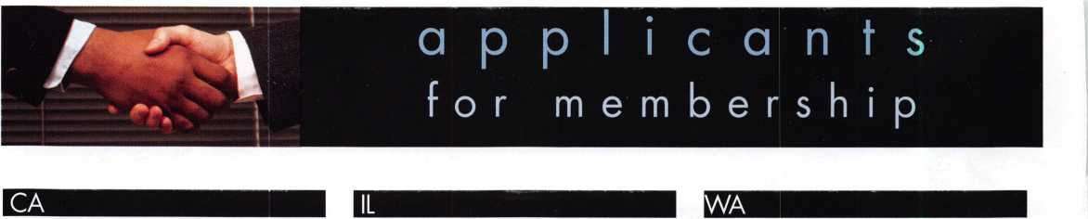
Hemet
Matthew Slusser
San Diego
Kamran Sajed
Tustin
Hitesh Patel
CT
Danbury
Daniel Abruzzese
Sponsor: Peter Sarailian CRL
Torrington
Michael W. Solak
Sponsor: Peter Sarailian CRL
FL
Boca Raton
Mike Rose
Sponsor: Dewayne A. Heidemann CRL
Maitland
Greg S. DeTardo
La Salle
Joseph D. Sibigtroth
MA
Boston
Luciano Lopresto
NY
Mahopac
Dennis Hymowitz
Sponsor: Peter Sarailian CRL
New York
Yuval Shenhar
Poughkeepsie
Curtis M. Ross
Sponsor: Peter Sarailian CRL
PA
Newtown
Nicholas W. Weaver ,
Sponsor: Ronald E. Weaver Jr, CRL
UT
Auburn
Joseph M. Henderson
Sponsor: Jim L. Jeffries CPS
Silverdale
Kenneth W. Clapper
Sponsor: Jim L. Jeffries CPS
Port Charlotte
Joe Moyer
Sponsor: Zachary Gilmore
Roy
Michael S. Thomas
Sponsor.■ Clifford D. Lipscomb CML, CPS
These applicants are scheduled for clearance as members of ALOA. The names are published for member review and comment within 30 days of this Keynotes issue date, respectively, to ensure
applicants meet standards of ALOA's Code of Ethics. Protests, if any, should be addressed to the Membership Department and must be signed. Active Membership applicants (a) have worked in
the industry two or more years. Allied Membership (AL) applicants are not locksmiths, but work in a security-related field. Apprentice Membership (AP) applicants have worked in the industry less than two years.
Keynotes • January 2006

REACHING NEW HEIGHTS
Albuquerque, New Mexico
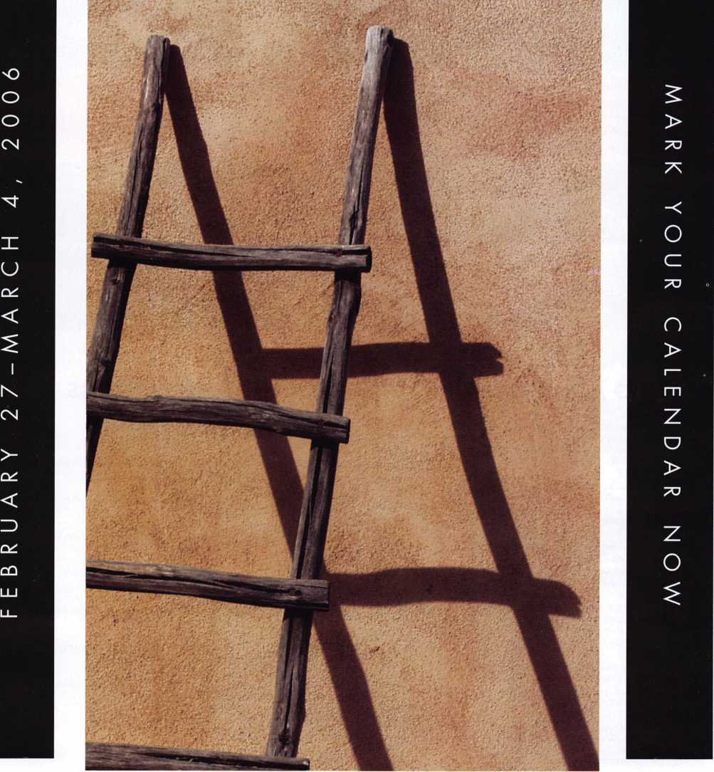
When it comes to learning about the
latest in safes and vaults, time is of the
essence. SAFETECH 2006 features an
all-new menu of classes, covering every
safe topic on the globe. Don't miss out!
SAVTA • 3500 Easy Street • Dallas, Texas 75247
(214) 827-SAFE (7233) Fax (214) 819-9736
Email: convention@savta.org
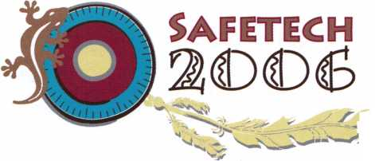

u p c o m
events
i n g
HAPPY NEW YEAR!!
04 Annual Oklahoma Master Locksmith Assc. Distributor's Show Contact: Mike McGrew, CRL 918-333-9136  Oklahoma City, OK | 10-12 Minnesota Chapter Associated 27 SAFETECH 2006  Locksmiths of America Safe & Vault Technicians Assc.  Education Weekend Annual Convention 2/27-3/4  Reservations, 651-770-2811 Contact: convention@savta.org  Maplewood, MN Albuquerque, NM
1-4 SAFETECH 2006
Safe & Vault Technicians Assc. Annual Convention 2/27-3/4 Contact: convention@savta.org Albuquerque, NM
6-7 Oklahoma Master Locksmith Assc.
2-day session
Contact: Mike McGrew, CRL
918-333-9136
Tulsa, OK • Holiday Inn Select
UPCOMING ACE CLASSES UPCOMING PRP SITTINGS
1/13-14/2006 Casper, Wyoming • ACE Classes
Wyoming Locksmiths Association
Contact: Darren McFarland, CRL
307-899-6018
2/1 1/2006 Detroit, Michigan • ACE Classes
Locksmiths Security Association
Contact: Robert C. Nobel, CPL
810-385-9329
2/10-12/2006 Minneapolis, Minnesota • ACE Classes
Minnesota Chapter of ALOA
Contact: Dana Lee, CML
612-968-4500
3/16-19/2006 Secaucus, New Jersey • ACE Classes
East Coast Region Security Show
Contact: Bill Timmann, CML
908-859-3135
4/22-23/2006 White River Junction, Vermont • ACE Classes
Green Mountain Locksmiths Association
Contact: Bradley Manchester
802-863-4153
4/22-23/2006 Fort Wayne, Indiana • ACE Classes
Northern Indiana Chapter of ALOA
Contact: Jeremy Rodocker, CML, CPS
260-459-1500
5/13/2006 Detroit, Michigan • ACE Classes
Locksmiths Security Association Contact: Robert C. Nobel, CPL 810-385-9329
1/12/2006 | Thursday 9:00 am • Dallas, TX • ALOA  Mayra Ocon 800-532-2562 x218
2/12/2006 | Sunday 9:00 am • Maplewood, MN • Minnesota Chapter  Dana Lee 952-887-1199
2/12/2006 | Sunday 8:00 am • Ft. Worth, TX • Texas Locksmiths Association 877-TLA-INFO
2/26/2006 | Sunday 9:00 am • Fairborn, OH • Ohio Valley Chapter of ALOA  Bill Lockwood, CRL 937-775-2154
3/04/2006 | Saturday 8:00 am • Albuquerque, NM • SAVTA '06 Satetech  Mayra Ocon 800-532-2562 x218
3/18/2006 | Saturday 11:00 am • Somerset, NJ • MLANJ  Bill Timmann, CML 908-839-3135
3/18/2006 | Saturday • Nashville, TN • Tennessee Org. of Locksmiths  Chris Cyree 931-455-0202
4/01/2006 | Saturday 8:00 am • Ontario, CA • California Locksmiths Association Suzanne Harmony 714-632-6800
4/06/2006 | Thursday 9:00 am • Dallas, TX • ALOA  Mayra Ocon 800-532-2562 x218
5/11/2006 | Thursday 9:00 am • Dallas, TX • ALOA  Mayra Ocon 800-532-2562 x218

core
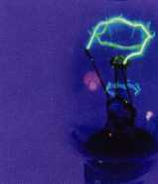
ALOA Members are Modern Marvels
The History Channel was at Hills Bros. Lock & Safe for two days in August filming
in the Lock Museum of Orange County. The show, A/lore Hardware will explain
retail hardware beginnings with the developement of sandpaper, wrenchs and
monkey wrenches, rope, hammers and LOCKS! Watch for comparisons between
the ancient Egyptians and Linus Yale, who had the same concept in the develop-
ment of the first pin tumbler padlock. Tom Nazziola has also done a piece about
push button mechanical locks. Check your listings for times/dates. There will be a
shared copy of the show available in the ALOA Library.
In Memory
Donald G. Dobs, R.L., passed away peacefully on October 24, 2005. Don was
the former owner of Minneapolis Lock and Key and former President of the
Minnesota Locksmiths Guild.
Drawing
ALOA Board Member, John Soderland, CML draw-
ing a ticket for the ALOA 1-day ACE class that was
presented as a door prize to the Minnesota Chapter
of ALOA at their banquet on December 7th. The win-
ner was Minneapolis Lock & Key of Minneapolis MN.
Schlage Computer-Managed Locks Protect Rock Valley College
210 CM Locks Cut Costs, Secure Central Illinois Campus
Ingersoll Rand Security Technologies' Schlage Electronic Security announced that Rock Valley College, a community college located in central Illinois, is using 210 Schlage Computer-Managed (CM) locks to secure its Support Services building, the Student Center and a mass communications lab that is open 24 hours a day. The college has already ordered 200 more CM locks for its Stenstrom Center for Career Education, which is located off the main campus.
Schlage CM standalone locking products provide features found traditionally with online, networked systems. User-friendly software on a laptop or PDA programs the locks, access trim, and offline hard-wired controllers, which manage strikes and magnets. New users, access points and access privileges can be programmed into a CM lock in seconds. Users can select proximity, magnetic stripe, PIN or i-Button credentials individually or in combination. The CM lock also provides an audit trail for download onto a laptop or PDA.
"The ability to use one card for all systems makes my life a lot easier," reports Rick Jenks, Security Network Administrator for the college. "Card access also promotes safety and security on campus. With the electronic CM locks, we can pick and choose access areas and maintain a certain security level. Security is not compromised."
Rock Valley College chose the CM locks and proximity cards because they integrated smoothly with the college's existing Andover hardwired card access system that uses proximity cards. All systems are transparent to the user and one card works an all readers.
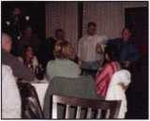
"There are major advantages to using the CM locks, particularly because of our many part-time teachers, who may not teach on a regular schedule," Jenks emphasizes. "We used to have to track their keys down because so many people would forget to give them back. Now we can program the locks to simply deny access after a certain date. This functionality saves us a lot of time and money."
Faculty members and staff used to have to carry several keys, and lost keys meant replacing both keys and locks. If a building master key went missing, Jenks would have to rekey the entire building.
"Manual keys are very expensive and time consuming," Jenks notes. "With the CM locks, we only have to remove the card that was lost from the system. This is a great reduction in overall long-term costs."
Jenks and one officer from the campus police department program the CM locks using a PDA and Locklink 7.0 software.
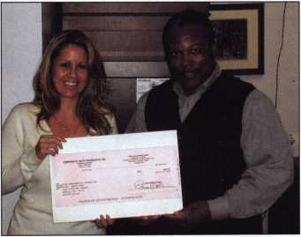
The college has found CM locks an ideal solution in applications where hard-
wiring is impractical or impossible. The first building to be outfitted with CM
locks at the college was the newly constructed Support Services building, which
houses maintenance, the campus police department and the financial services
office. The second building to be completed was the Student Center, which was
undergoing renovation and required upgraded security.
Rock Valley College has already ordered 200 CM locks to secure its new offsite
facility, the Stenstrom Center for Career Education. Because that building is at a
remote location, campus officials decided it needed the increased security of elec-
tronic locks. Older on-campus buildings will also be retrofitted with CM locks as
funding becomes available.
"We chose Ingersoll Rand because they are known to produce quality products
and they've been around for a long time," Jenks concludes. "We didn't want to
invest a substantial amount of the school's money in a company that might not
make it in the long run. We also wanted to make sure that the company would
stand behind us. Ingersoll Rand is very good with immediate assistance, which
helps avoid long-term problems."
Corporate Safe Specialists Present Check to ASF
Corporate Safe Specialists presented a check in the amount of 504.00 to t
he ALOA Scholarship Foundation during the 2005 ALOA Convention and
Security Expo. The company also rewarded attendee winners with trips to Hawaii
as follows:
Hoogerhyde Safe Co. in Grand Rapids, Ml
Whitlow Security in West Allis, Wl
Keystone Lock in Deerpark, NY
Keynotes • January 2006

Fingerprint Access Control

-mMrn
»r
I
Keynotes • January 2006
ekeyUSA Systems, LLC is the North American supplier for “ekey biometric systems” in Austria, where ekey TOCA products and technology are developed and manufactured, ekey biometric fingerprint access control systems come in several models beginning with a basic stand-alone system. It does not require a computer to operate or enroll/delete users for one-entry-point/function and extends to networked systems consisting of multiple readers to control multiple entry points with functions that allow access rules to be set and an audit trail showing who entered, at what time, and at which entry point they were assigned access.
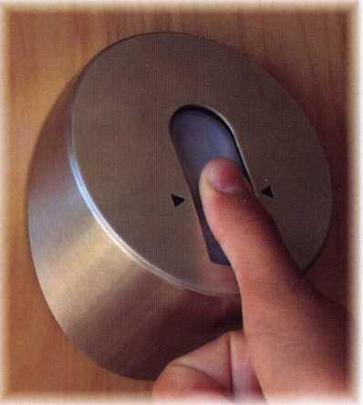
ekey TOCA systems operate electronic locks or any normal open-close functioning doors, cabinets, boat lifts, home offices, garage doors, industrial machinery, or restricted areas. Both stand-alone (TOCAhome) and networked systems (TOCAnet) can be used for the simplest single entry to the more complex multiple entry, residential or commercial applications.
There are 3 models of ekey TOCAhome systems and all come with 1 reader, 1 control panel, and one power adaptor. The basic system, TOCAhome, comes with 1 relay for a single-entry point or function. Models TOCAhome3 and TOCAhome pc have 3 relays and a different finger is assigned to each of the 3 relays.
TOCAhome pc comes with RS232 interface (software included) and is an affordable option if a simple audit trail is needed. The system also allows adjusting strike times and enrollment at the computer if desired. The control panel does not need to be connected to the computer to function.
ADVANTAGES
- Thermal scanner combined with “sweep” method makes the reader self cleaning leaving no latent fingerprint
- LED intuitive indicators on reader (green, yellow, red)
- Quick and easy enrollment procedure (Delete procedure is even faster)
- Key over-ride
- Variety of Stainless Steel reader covers for decor or extra protection
- Weather resistant reader for inside and outside use
- Fingerprint minutiae are extracted and stored as irreversible data rather than the fingerprint image
- Durable sensor resistant to dust, heat, light, pressure and electro-static discharges.
- Different fingers can be assigned for different doors/functions (TOCAhome3 and TOCAhome pc). For example, a user can use their index finger to open a door and a thumb to open a garage door.
Keynotes • January 2006

ENROLLING USERS FOR STAND ALONE SYSTEMS
TOCAhome stand alone systems store up to 99 fingerprint templates and users are quickly enrolled at the control panel (usually taking less than a minute). TOCA home control panels have a 4 button keypad providing backward (cancel), forward (OK/enter), and left-and-right directions following a simple menu.
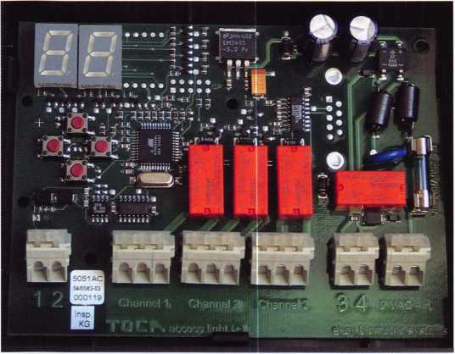
An assigned individual (system administrator) enters a 2-digit code to operate or program the system. Enroll appears as EU on the panel (press OK). Then, scroll to the right to find the next unassigned user number (press OK).
Assign the finger chosen to use (any of 10) then press OK. Assign the relay for that finger to operate, if model contains more than 1 relay (press OK). The LED on the reader appears yellow, meaning it is ready for fingerprint template to be stored.
Next, instruct the user to place the designated finger flat on the reader and swipe it straight down the length of the entire reader at a medium speed with slight pressure (NOT pressing or pushing). The LED on the reader will appear “green” indicating successful enrollment.
To delete users, begin from the 2-digit-code step and scroll to delete (DU). Next, scroll to the user number, which should be kept on a log sheet. Press OK and that user no longer has access rights.
INSTALLATION
TOCAhome systems consist of the reader (approx. 2” x 4” x 2”), control panel (approx. 5” x 5” x 2”), and a power adaptor. The reader (outside unit) is mounted on a wall using a bracket with 2 screws. The unit should be installed at the recommended height of 52 inches. The control panel also comes with a bracket and 2 screws to mount on the wall. The control panel slides onto the bracket. The control panel can be installed in a control room, closet, garage, or any concealed area near a regulated AC/DC power source. Also needed is a separate power supply for the locking device.
In most installations, shielded CAT5 can be used depending on the distance between the reader and the control panel. 4 wires are used from the reader (labeled) to the control panel (labeled); 2 for power and 2 for data. Each relay has a common, normal open, and normal close. The reader is powered from the control panel, 9VAC from supplied external adaptor or regulated 12VDC. If desired, regulated 12 VDC could be used.
For more information, contact ekeyUSA Systems, LLC, 6150 53rd Avenue East, Bradenton, FL 34203. Telephone: 941-782-1227, Fax 941-256-3555. Website: www.ekeyUSA.com

2
Keynotes • January 2006

Mi
SECURITY HOMEOWNERS WANT. That’s WHY It’s ALL YOU NEED TO CARRY.
Introducing the Schlage Accents™ Collection
Schiage now provides you with the ability to retrofit virtually any door with the ultimate
in elegance and security. The Schlage Accents collection is built on a revolutionary
chassis designed to provide field-reversible levers on passage, privacy and now keyed
functions. A patented adjustable through-bolt allows Schlage Accents handlesets to
retrofit over 7Q% of competitors’ current designs. Special features like these, along
with concealed screws and decorative trim,
'•''XHM&t.je:* •- - - * ' - . ' ‘
allow you to reduce the inventory you
carry while providing the perfect door hardware choice for homeowners who desire
Schlage quality and security.
To find out more about the finest line of decorative door
hardware, visit schlageaccents.com.
ACCENTS
■ 'Ttmdess beauty _{t}
An(fff)lngerS0l!1tanii business
© 2005 ingersoll-Rand
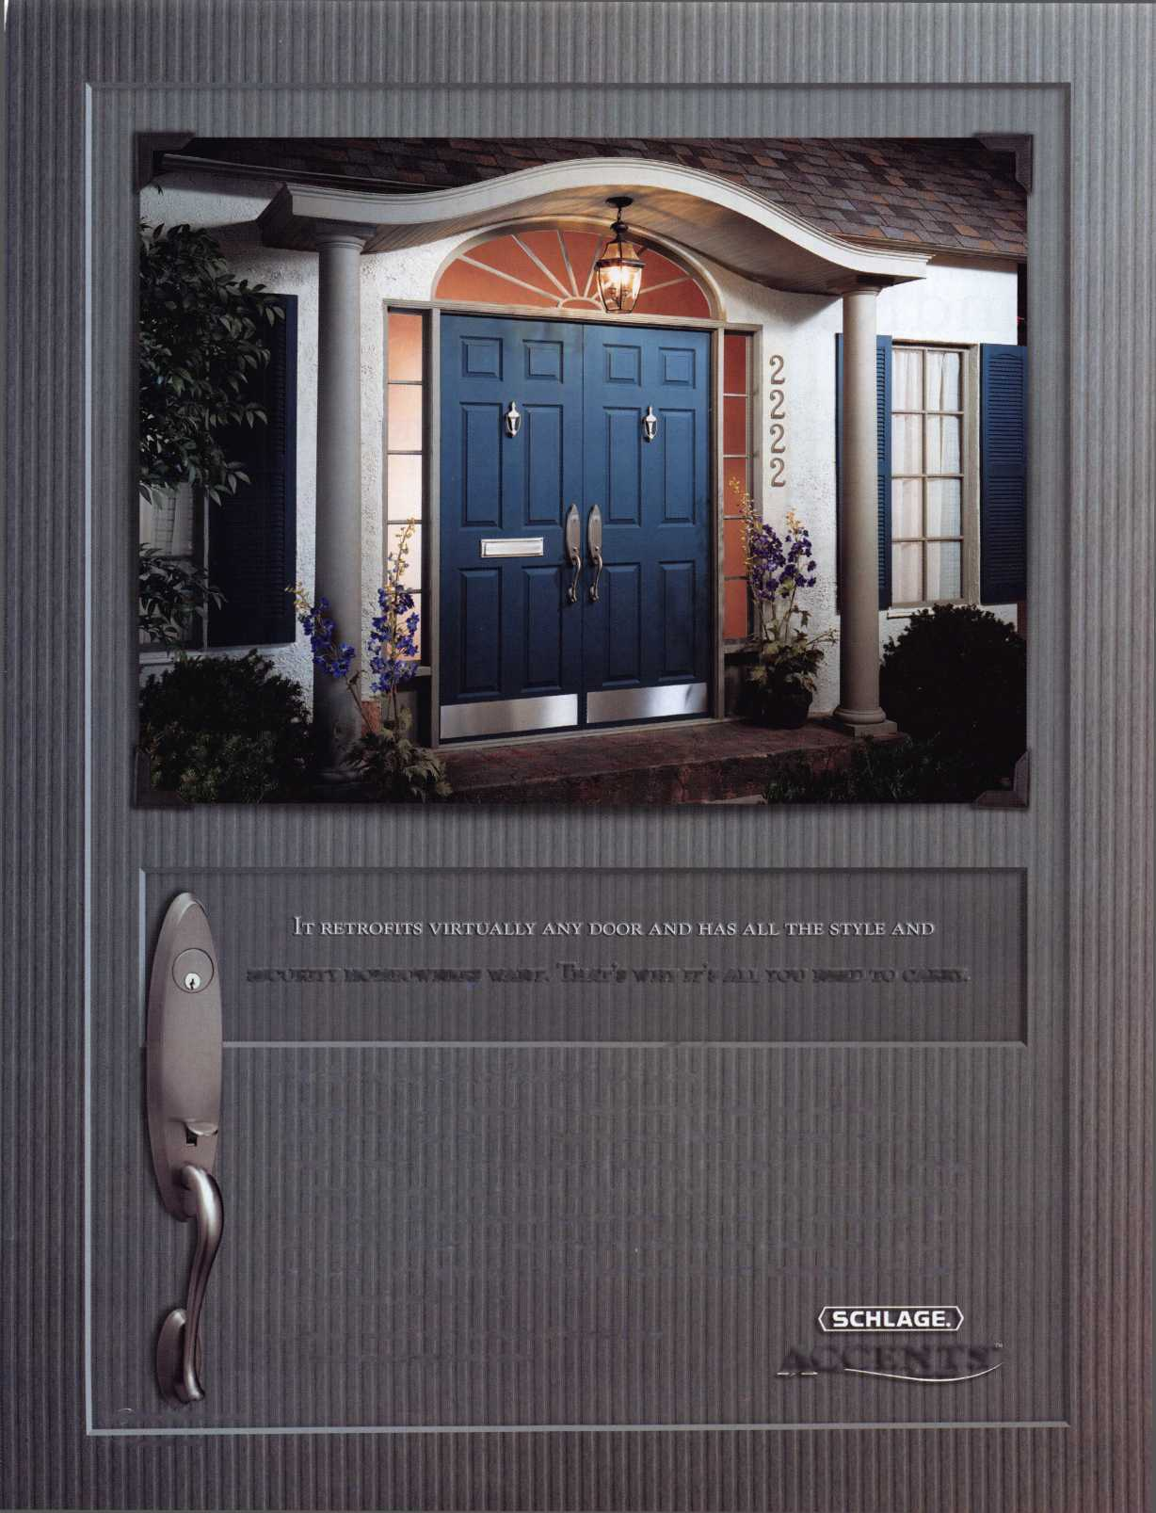

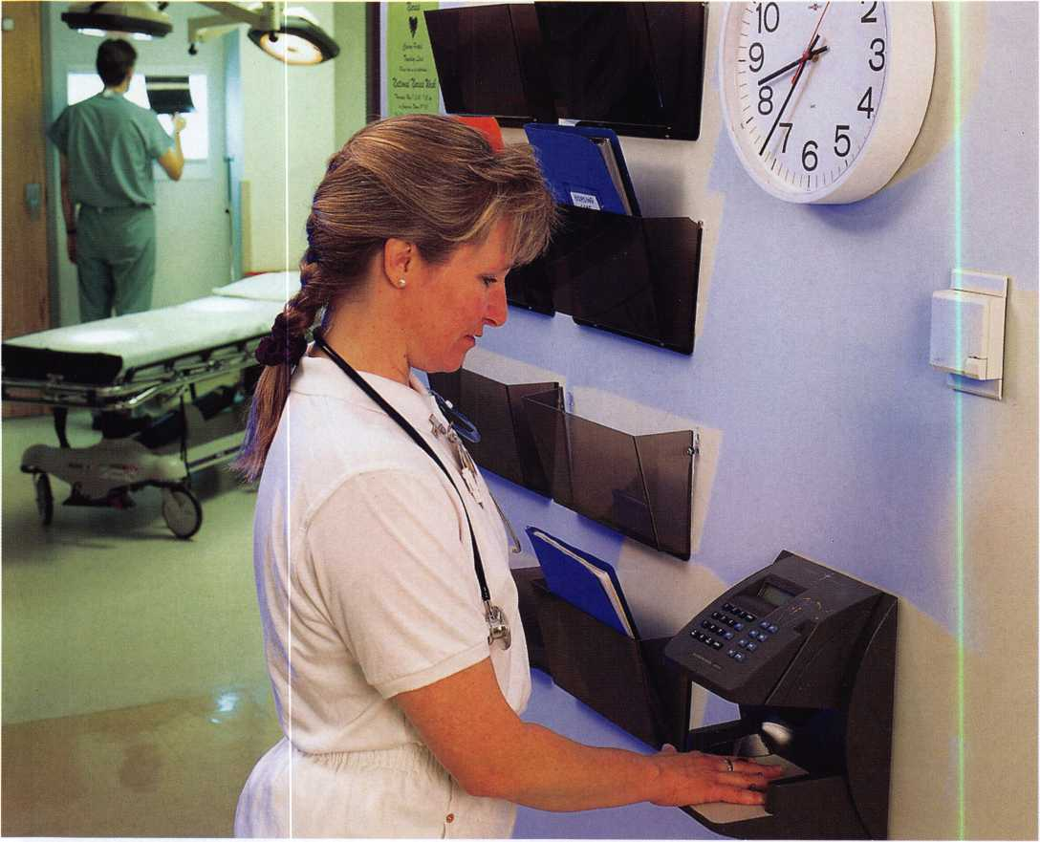

Aspirus Wausau Hospital Prescribes Biometric HandReaders for Security
50 HandReaders Provide Access Control for Medical Center's 3,000 Employees
Keynotes • January 2006

Recognition Systems, the biometric component of Ingersoll-Rand's (IR) Security & Safety's Electronic Control Systems, announced today that Aspirus Wausau Hospital in Wausau, Wisconsin is using 50 of its biometric HandReaders to ensure only authorized individuals access hospital grounds. Aspirus Wausau Hospital serves the health care needs of residents of Wausau and a 12-county region of northern and central Wisconsin.
Over 3,000 Aspirus Wausau employees are enrolled with the HandReaders, which automatically take a three-dimensional reading of the size and shape of a hand and verify the user's identity in less than one second. Recognition Systems was named recipient of the 2004 Application Market Penetration Leadership Award for access control and time and attendance applications in Frost & Sullivan's study, World Biometrics Market.
"We chose biometrics because of the high cost of using access control cards," explains Greg Pehlke, Security Supervisor for the hospital. "We were spending $2,000 a month on smart cards with computer chips, which employees were simply loaning to unauthorized individuals. Much of this cost, and the security breaches, have been eliminated with the HandReaders."
Aspirus Wausau Hospital's previous card-based system had reached full capacity, and it would frequently freeze up. During the transition to biometric access control, the hospital had a dual system running with both card and HandReaders. Now, however, the hospital is using only HandReaders for access control.
The hospital's 50 HandReaders, including rugged outdoor models designed to handle inclement weather, control access to the hospital. The front entrance is locked down after visiting hours and only authorized individuals can enter at that point. The HandReaders are networked and all security systems are monitored from the security department's dispatch center.
Hospital officials have found hand geometry to be more reliable than other biometric technologies they researched, Pehlke emphasized. There are fewer false reads with HandReaders and fingerprint scanners just don't work for large user populations.
The hospital will be adding six new readers this year. More departments are requesting the HandReaders so that they can eliminate keys and increase security, Pehlke said.
HandReaders handle any population volume with ease while providing impeccable reliability. With dramatically lower false reject and failure to enroll rates than other biometric technologies, the value of HandReaders grows as the number of users and/or transactions increases. They are recommended for outdoor applications.
About Recognition Systems
With over 100,000 hand geometry units throughout the world reading millions of hands each day, IR Recognition Systems, founded in 1986, is the pioneer and only manufacturer of the leading two biometric technologies, hand geometry and finger scan. The world sales leader of biometric verification devices used in access control, time and attendance and identification applications, it serves an international clientele from its headquarters in Campbell, Calif. Its website is www.handreader.com. Phone is 408-341-4100. Recognition Systems is the biometric business unit of Ingersoll-Rand's Security & Safety's Electronic Control Systems. Ingersoll- Rand is a leading innovation and solutions provider for the major global markets of Security and Safety, Climate Control, Industrial Solutions and Infrastructure. Ingersoll-Rand's website is www.irco.com.
15
Keynotes • January 2006

One-Way Cylinders
by: Eric Costley
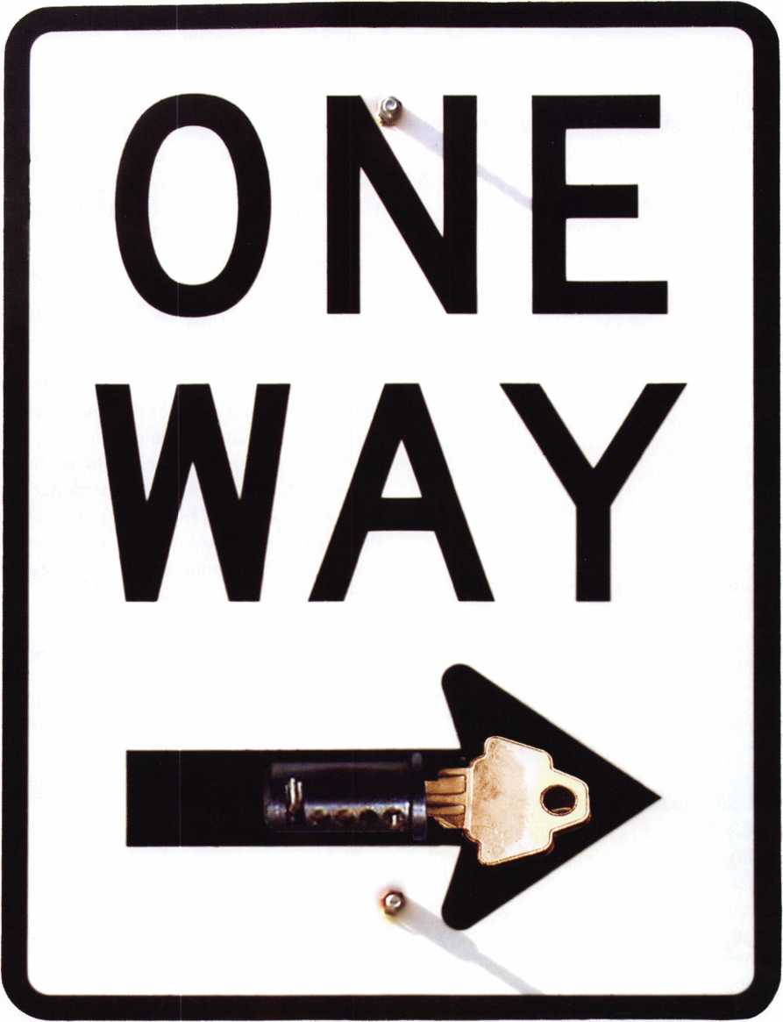
Keynotes • January 2006

Some of you are probably wondering what a one-
way cylinder is, and what on earth you might use it
for.
I’ll give you a little background as well as a few
possible scenarios that would require such a cylin-
der. I will also teach you how to manufacture your
own in minutes, in case you ever get a call for such
a beast, or dream up this as a solution for a cus-
tomer’s problem. If done properly you could gain a
customer for life.
It’s an “old secret” that dates back beyond universal
pin kits, back to the times when a locksmith played
his hand close to his vest and was reluctant to show
even his own apprentice a few tricks!
My first “new” call for a one-way cylinder came
from a high-rise apartment complex on the beach
near Wilmington, NC. The exterior door of the
complex was equipped with an Adams Rite latch
lock, and some of the tenants had discovered that
by depressing the paddle handle and turning the
key toward the hinges, they could lock the latch in
the open position. This was convenient for the ten-
ant if they were having wild parties because the
exterior door was open at all times. It was, in turn,
frustrating for the security guard, who was respon-
sible for locking the door at 5 p.m. so that only ten-
ants would have access to the property.
After selecting a cylinder, remove the plug and pins. Select a drill bit that is the same diameter as the pin chamber, (or slightly larger,) and start drilling at a 90 degree angle from the pin chamber on the appropriate side of the plug. Be careful not to damage the existing pin chamber bore, and stop and measure frequently to achieve the desired depth.
_{A/r} i hi r* it . The finished "generic" one-way, (which can be set up for either
Management had called a few Other locksmiths in direction,) and the three operating keys: One turns both ways, one to
the area, but was daunted by the perplexed looks ^{the r}'9^{ht} only, and one to the left only,
and expensive solutions offered by my competition.
It took one good night of “I’ll sleep on it and get
back to you” to realize how I would tackle the situ-
ation.
Here’s the beauty of a one-way cylinder: without a
single master wafer, you can convert it from turn-
ing in both directions to turning in one direction
only. This not only applies to mortise cylinders, it
can be implemented in virtually any pin tumbler
cylinder that you encounter (including some high
security cylinders), with only slight modification of
the plug.
The key which is currently inserted in the plug will allow the cylinder to turn to the right, but not to the
left."\
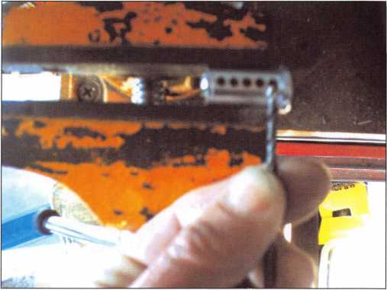
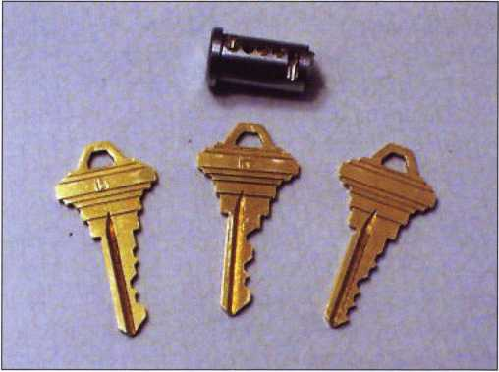
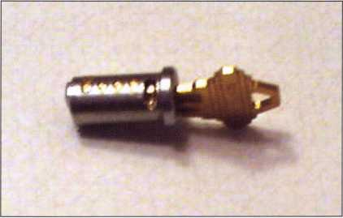
Keynotes • January 2006

When incorporating such a cylinder into a mas-
terkey system, one must be careful not to create
interchange, but that situation, (thankfully,) is rare.
If a masterkey system maintains a solid pin, (i.e. no
master wafer,) in a single chamber, that chamber
can be utilized to create a one-way cylinder with-
out compromising the existing system.
One of the other inherent beauties of this sytems is
that the one-way keys always contain a cut which is
deeper than the owner’s key, so that existing one-
way keys cannot be filed down to compromise the
cylinder!
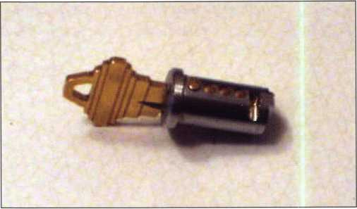
This key will allow the plug to rotate to the left, but will be blocked when attempting to turn to the right.
By cutting the plug, (I recommend that the depth
be .045" to .060", to ensure that you have a steep
stop on the interfering side) you can make a cylin-
der that turns in only one direction, as the top pin
drops down too far to allow the plug to rotate in
the other direction. By cutting a key that is shal-
lower, (by whatever depth you have cut the step in
your plug) you have a key that will turn in both
directions. There are, however, some severe draw-
backs to making a one-way cylinder.
One of these is that by creating a “stepped” shear
line, you have created a lot of extra space in the
plug. If the step of the new shear line is at a depth
of .410" instead of the usual .500", a whopping
.090" of space remains! If the original manufactur-
er’s specifications call for depths that are managed
in increments of .015", there are 6 possibilities
between the “two-way” key and the “one-way” key
in that pin position. While the key depths between
these two may not operate smoothly, there is a pos-
sibility that one or more of them might manage to
actually operate the cylinder with a little finesse’. It
all depends on how accurately you have machined
the new shear line.
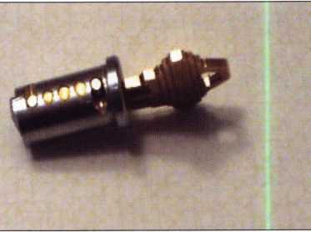
The original key, which is uses shallower cuts in both the first and last position, allows the plug to rotate in both directions. This would be considered the "owner's key".

8
Keynotes • January 2Q06

IAS VEGAS
>
fverV
bodV ^{Wf}>«ts it

FKI
SECURITY GROUP
((S) Security & Safety
SECURITY PRODUCTS
.You MIGHT TAKE
IT HOME!
One Lucky Member Attendee at ALOA
2006 is going home with this gorgeous
mint-condition 1956 Ford Thunderbird.
A ticket will be given to each ALOA
Member who registers and attends the
show. Someone has to win it, and it
might as well be YOU!
(Must be present to win. Exhibitors,
Employees. Family Members of Employees, and
nonmembers are not eligible for this door prize.)
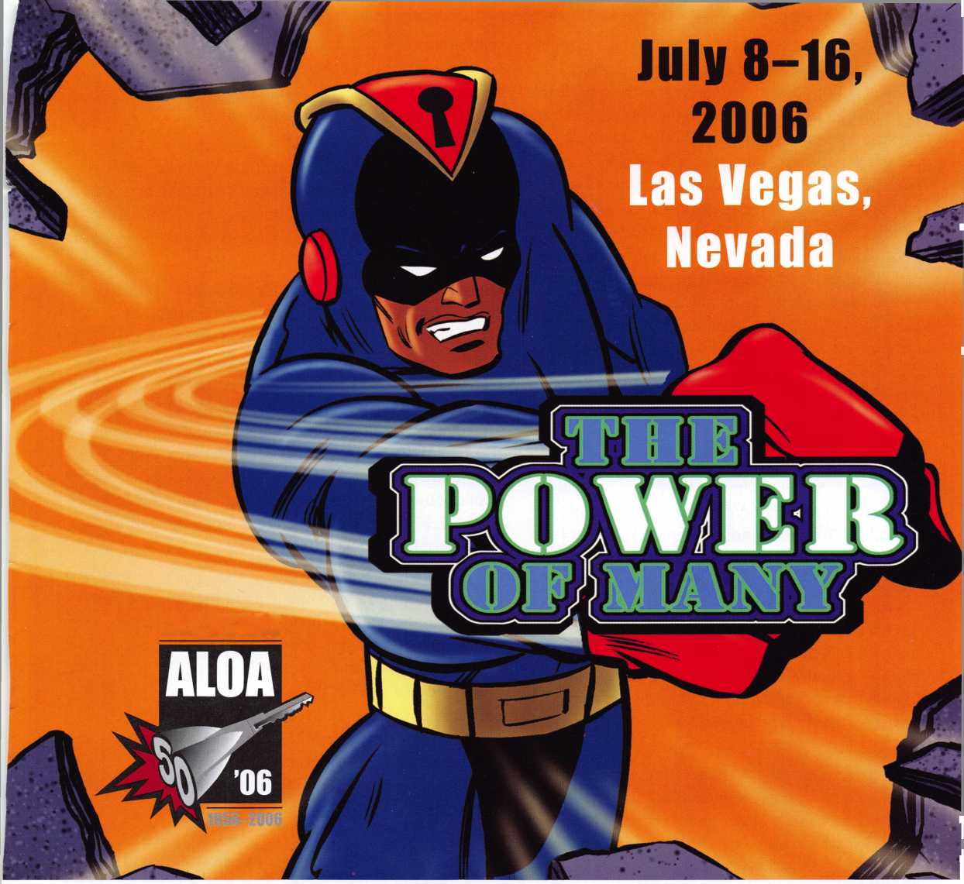
For the sake of convenience, I have taken a standard mortise cylinder and converted it to a one-way cylinder in both directions, using the first pin chamber to restrict one direction and the last pin chamber to restrict the other. It is unlikely that you would ever get a call for a cylinder which is capable of restricting rotation in both directions but unless you know the handing of the door on which you are installing it, you don’t know which side of the plug to cut! By using two pin chambers and opposite sides, I’ve set up a “generic” one-way cylinder that can accommodate virtually any need, depending on which keys I choose to implement. Since the standard pin size is about .115", we pick a corresponding drill bit and carefully create a 90-degree “step”, one on each side of the plug. One of the drawbacks to using a .090" step is that the cylinder operates with a bit of a catch, no matter which key you are using. As the step gets deeper, the edge of the cut must conform more to the original curvature of the plug to allow smooth plug rotation. This, in turn, allows for greater tolerance and key interchange. I would recommend that the stepped shear line not be more than .060", simply to restrict key interchange and to avoid sloping the step any more than necessary. (I’m sure that the photos explain it much better than I can in words!) If I had used a cut-away cylinder, the results might be a little more obvious, but seeing the plug out of the housing gives a pretty clear picture as well.
Another recommendation concerning the use of one-way cylinders: use a good solid brass cylinder. There are thousands of cheap pot-metal cylinders on the market whose tolerances are sometimes ridiculously liberal. In addition, the metal tends to wear away and distort the plug and the cylinder housing if keys that are inaccurate are utilized. Since the keys and pins are made of better material than the cylinder itself, it becomes the weak link in the chain. You can use this technique on such cylinders, but it is apt to come back to bite you later. Your customer is relying on you to provide a solution to a complex problem. They will be glad to spend a little extra for a quality cylinder, or even a new lock if you say it is required. Of course, you should charge a premium for such a cylinder modification. Even
with practice, it will take you at least an extra half an hour to set one of these up. Add your labor time right into the price of the cylinder, and add a little more for your experience and knowledge.
As a friend of mine once said, “You’ve made your castle of sand, now bring it home.”(After all, an idea might be nice in theory, but unless you have a valid application, it remains just a useless idea.)
One-way cylinders are great for “absentee” employers, who wish to restrict re-entry to the premises. Bartenders are notorious for locking up, and then returning later to entertain their friends at the owner’s expense. If the key can only lock the door preventing re-entry only the owner’s key can allow after-hours consumption. I’ve had similar requests from tanning salons, who claimed that employees were allowing their friends to “tan for free” after hours. (How shallow is that? Jeopardizing your job for a “free” tan in a beach community? The gall of some people amazes me!)
Also, an employee who opens up in the morning canno simply clock in, lock the door, and re-enter just before their shift is over to clock out. (Downside? They can leave the place totally unlocked!) Of course, the obvious solution is to only hire employees that you can trust completely, or be a hands-on owner. Still, employers will often become complacent and opt for simple and inexpensive solutions, which fix the symptom but not the problem.
The best solution for such a situation is to install an access control system on the door which is equipped with audit trail capability so that the owner knows who has activated the lock at any given time. Many such systems can also restrict the hours in which any given employee can use the lock. They are much more flexible than our simple mechanical cylinder. A lot of small business owners don’t want to go the extra expense for such a system, primarily because they are usually renting the space. Still, it doesn’t hurt to suggest the “best”
(and more profitable) scenario before resorting to a
20
Keynotes • January 2006

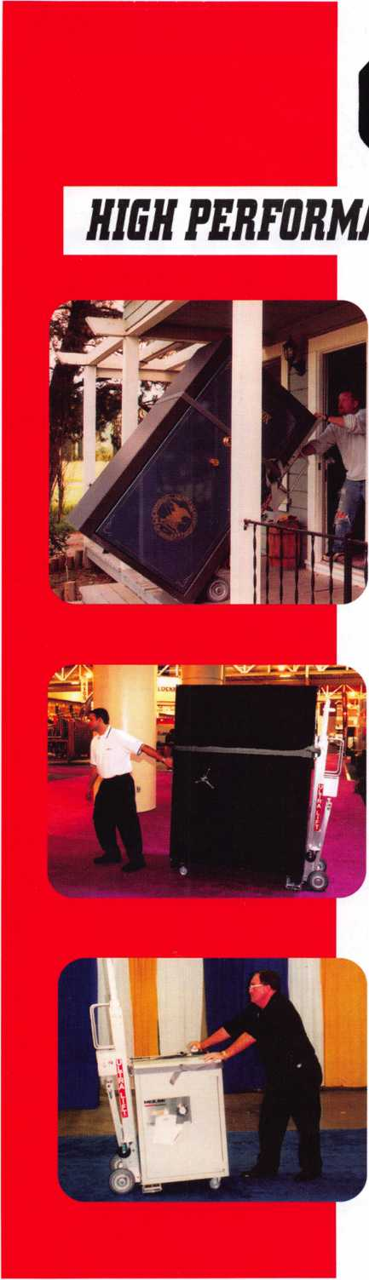
OPERATOR SAFETY
Injuries can be virtually eliminated. Ultra Lift does the lifting so that operator effort required to complete a move is minimized. Heavy loads are broken back with ease. The operator stays in control by using a combination of motor power, balance and leverage in every phase of a move.
REDUCE LABOR COSTS
Fewer people are required for any move with Ultra Lift. Manpower can be scheduled more productively. Labor savings often pay for the Ultra Lift in one month.
ELIMINATE DAMAGE
Loads are broken back, set down and moved under power with maximum leverage and operator control. Gentle handling eliminates bumps, bounces and damage to the load and premises.
INCREASE PROFITS
Increased operator safety, reduced labor cost and elimination of damage to the load and premises all contribute to significant increases in profits.
FOR LITERATURE, VIDEO OR ON-SITE DEMONSTRATION, WRITE OR CALL:
ULTRA LIFT CORPORATION
475 STOCKTON AVENUE, UNIT E SAN JOSE, CA 95126 800-346-3057 408-287-9400 FAX 408-297-1199 E-mail: info@ultraiift.com www.ultralift.com
U.S. PATENT 4.570,953
ULTRA LIFT supplies the power - so you don't have to. One person can safely and easily handle loads that usually require 2 or 3 people, even up or down stairs. Two people can handle most safes to 1500 pounds. If safety is your concern, ULTRA LIFT is the best move you'll ever make!

ea&

RING of a KING
Sponships Peter R. Hall 17
Kwok-kei Leung 220
Henry W. Raymond 91
Yuriko Yanai 82
Mary S. Ohmit CPL 66
Charles C. Robertson CML 65
William Lee CRL 62
Jack Hobin CPL 51
Clifford D. Lipscomb CML, CPS 52
Michael B. Groves 48
C Allan Halverson 40
David M. Troiano 51
Myeong-Rae Cho 38
Jim Williams CRL 42
David M. Lowell CML, CMST 36
Salvatore J. Dulcamara CML 36
Dana L. Barnum CML 35
Barry K. Leas CRL 35
Danny W. Rudd CPL 31
Larry A. Warnick CML 31
Eugene R. Altobella Sr 31
Jeanne G. Lodge CML 30
Robert D. DeWeese CML 31
Scott L. Henke CPL, CPS 29
Dallas C. Brooks 28
Breck H. Camp CML 27
Lawrence F. Smith Jr, CML 27
John C. Elliott Jr, CML, CPS 28
Marian M. Swann CRL 27
James M. Watt CML, CPS 26
Robert W. Duman Sr, CML 31
William L. Young CML, CPS 33
Anthony J. Ramunno CML, CPS 24
Jeffrey S. Nunberg CML, CMST 26
J Thomas Hood CML 26
Ken Dale 26
Robert H. Stafford CML 25
Philip A. Rovenolt CPL 25
William T. Beranek 29
John L. Shandy CML 25
Elvis D. Hammerschmidt CPL 25
Jerome L. Cohen CML 22
Peter K. Gauthier CPL, CPS 22
Man-Soo Seo RL 23
James J. Cawby CML, CPS 22
James L. Hancock CPL 29
Hans Mejlshede CML 25
John S. Dorsey CML, CPS 20
Thomas G. Vandersteen CML, CPS.. 19
Peter Sarailian CRL 29
Walter W. Lascar RL 18
Keizo Takahashi CRL 18
James E. Fowler Sr, CML 18
David C. Harris CML 18
Ronald E. Heidzig 1 8
Joe J. Lee CRL 18
Takashi Kuwana CRL 19
Eugene R. Altobella Jr 17
Ernest W. Wright 1 8

William P. Grant CRL..
James E. Gruber CPL 18
Evelyn V. Wersonick CML, CPS 15
Joseph P. Ferrero CML 15
Gary F. Teams CPL 14
Kenneth E. Kim CRL, CPS 16
William J. McElheney CML 1 8
John W. Soderland CML, CMST 15
Michael E. Jordan Jr, CML 15
Jon B. Griswold CML 16
Brian J. Reetz 15
John A. Ilk CRL, CPS 16
Russell P. Fuller CRL 16
Robert C. Rodocker CPL 13
John J. Greenan CML, CPS 15
Steve L. Cothran 15
Leonard J. Passarello CPL 14
Bruce J. Tarbet CML, CPS 12
John D. Cannon CML 14
Paul M. Souber 14
James T. Brickler CPL 14
Calvin G. Harris CML 13
Frank D. Hartung CML 13
Rolando Bouza 13
John F. Engel CRL 14
Richard C. Sievers 14
Brooke P. Berry CRL 13
William J. Wickward CML 12
Raymond C. Lusk CML 10
Robert M. Massard CRL, AHC 12
Gregory L. Perry CML, CPS 14
Eric F. Veal 12
Barry L. McMenimon CRL 12
Thomas J. Demont CML, AHC 11
Basil W. Shannon CPL 12
Ralph O. Warren CML 10
Gordon R. Racine CML 11
Kevin R. Wilson CML, CPS 11
Timothy K. Chow 10
Dale L. Knowles CPL 11
Timothy J. Moore CRL 13
Andrew A. Edmunds CML, CPS 11
Daniel S. Enriquez CRL 11
Gene Eldridge CPL 10
Ronald P. Riggins CML 11
Charles E. Haas CML 10
Robert E. Mock 12
Lester S. Brodsky 10
Larry L. Votaw CML 10
Thomas R. Smith CPL 10
Todd K. Ladwig CML, CPS 10
William T. Straub CML 10
Randy L. Hutchison CRL 10
Richard T. Johnson CPL 10
Vincent L. Formon CML, CPS 10
Carroll T. Croson Jr 10
Marian E. Sagar 10
Andrew S. Dennison CPL, CPS 10
How can I join the President's Club?
You can earn a membership in this prestigious club by recruiting
just 10 new members for ALOA.
*Any ALOA member may participate.
What do I get?
When you recruit 10 members, you receive a
handsome blue blazer with a President's Club crest.
For each additional five members you recruit, you
receive a lapel pin with gold-filled numbers, indicating,
your recruiting successes.
You also get the satisifaction of knowing that you are
helping your association, helping your industry grow,
and you are helping fellow locksmiths achieve success.
How do I get started?
Mail the form below to the ALOA office for a supply of
applications (800) 532-ALOA or FAX (214) 819-9736.
One President's Club credit is awarded for each new
applicant. Credit is awarded only after the membership
application is pproved. However, the credit will apply
for the period in which the application is received.
Failure to identify yourself as the sponsor on the applica-
tion form at the time it is submitted to ALOA for process-
ing will forfeit any credit.
Yes! I want to join the ALOA President's Club.
Please rush me applications so I can start earning credit toward membership in the club!
Name
Company
Address
City
Zip
Mail this form to ALOA • 3500 Easy St. • Dallas, Texas 75247-6416

less-expensive alternative. Your customer will respect the fact that you can give them more than one possible solution to their needs.
Will you get swamped with calls requesting these? Probably not. However, word of mouth is, was, and always will be the best advertising you could ever want and it doesn’t cost you anything. All a customer ever requires (and it’s a great deal, depending on the situation) is that you find a way to meet their
security needs in a timely, affordable way. As I said before, once you’ve showed that you can overcome the problem and the competition without duress to either you or the client, you have a customer for life and that eventually translates to money in your pocket.
Next time you encounter such a situation, remember: there IS a solution!

THE HINGE DOCTOR
by GKL Products
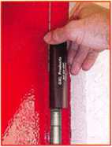
HA1 For
Standard
Commercial
4-1/2” x 4-1/2”
Butt Hinges
HA2
"The HULK"
For Residential Hinges
COMING IN
SEPTEMBER
HA3
For Ball- Bearing
Commercial Hinges
The Hinge Doctor is a great way to repair those sagging metal
doors. Slip the tool over the hinge and open the door an inch
or two past the point where the tool binds against the
hinge, remove the tool and check the door,
which should now be working properly.
If you're a locksmith these tools
will turn a profit the 1st time you
use them!
Uses - schools, hospitals,
commercial buildings, storefronts
with butt hinges, office doors, new
construction, door alignment, sagging
doors, jail cells, anywhere there are
commercial grade hinges.
HA4
For Prison
& institutional
Hinges &
Spring Hinges
US Patent #6450003
www.hingedoctor.com
800-924-5397
Over
10,000
Satisfied
Customers
Keynotes • January 2006
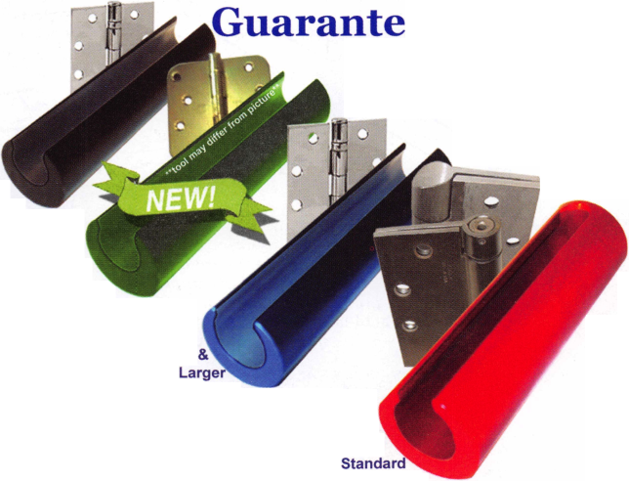
OUT OF TIME ?
By: Claire L. Cohen, CML
Are you out of time? Do you feel as though you need more hours in a day to accomplish your work? Your time at work is precious. For the security professional, you have a great deal to do, and your time is valuable. Perhaps the answer to maximizing your productivity is to focus on how to manage time efficiently.
to recognize the factors that can make us attempt to achieve the most from our working day. Also, we need to isolate factors that make it more difficult for us to accomplish our work and exert a positive influence over them.
PHYSICAL ENVIRONMENT
Does this sound familiar? You start your work day knowing
exactly what you want to get done. And then what hap-
pens? You face all kinds of unexpected demands
from others—from the boss, from co-workers,
and/or from customers. And, if you are
not careful, you spend most of your
time reacting to these demands. The
day, week or month is gone, and
you are frustrated!
Every unscheduled phone call
or potential customer walk-
ing in the door creates a
modification to our planned
work schedule. In a service
business, many times this is
extremely welcomed!
However, disruptions to our
routine stop us from doing
what we planned to do. We
need look at each interruption as
it happens, and allocate time to it
as we see fit. Effective time manage-
ment enables us work to make sure that
what happens during the unplanned visit or
telephone call is what we want to happen
There is a direct relationship between the physical organi-
zation of your work space and your productivity. This
holds true for those working on
a service vehicle, in a
retail environment
or an office. If
you don’t
make the
most of
your
work
space
you
not
most
out of
your
time.
The three
areas of con-
centration
should be tidiness,
comfort and structure.
Don’t get caught in the trap of just moaning about the things you can’t accomplish. Take a proactive approach. As far as possible, control the things in your environment that you CAN control and impact your time. Your work surroundings contain factors that can either help you to work to your maximum, or hinder you from doing so. We need
Insure that your workspace is tidy and organized. Are parts systematically organized and labeled? Can you find everything quickly? Are you wasting time looking for parts, rather than installing them?
Are you comfortable in your work environment? Your concentration level and overall ability to work will be reduced
Keynotes • January 2006
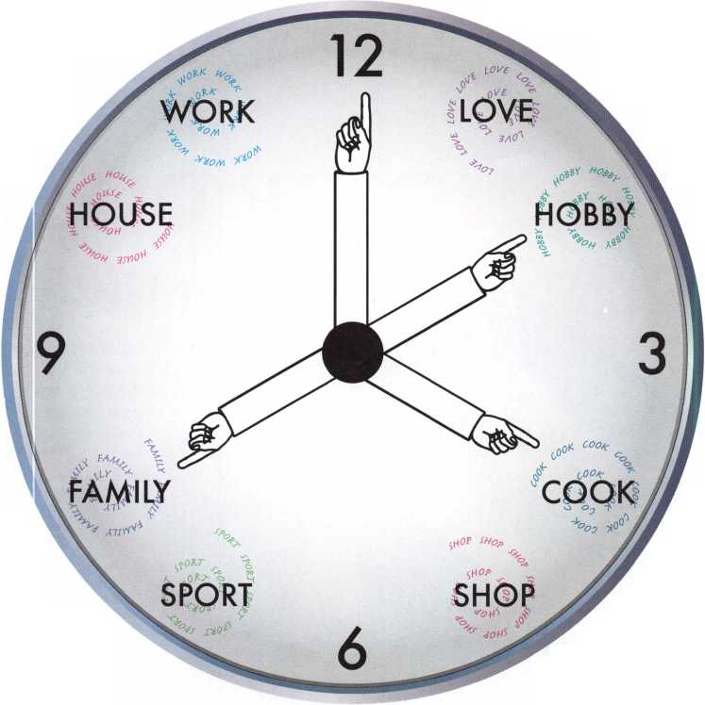

A Division of The Eastern Company
301 West Hintz Road Wheeling, IL 60090 Telephone: 800.733.8588 Fax: 847.537.1881 www.cc I sec u rity.com

Features & Benefits
Industrial Strength Combination Lock!
Resists Hammer and Re-bar Attacks!
Hardened Steel Full Metal Jacket!
Hardened Steel Full Metal Jacket Shroud!
Weather Resistant Black Electrocoating!
7/16” Chrome Plated Molybdenum Shackle!
Inside Shackle Clearances: 1” and 2”!
Shackle Pull Strength: 2,750 pounds!
All Brass Inner Mechanism!
Four All Brass Dials!
10,000 Changeable Combinations!
Quick Delivery: Shipped from Stock!
Locks
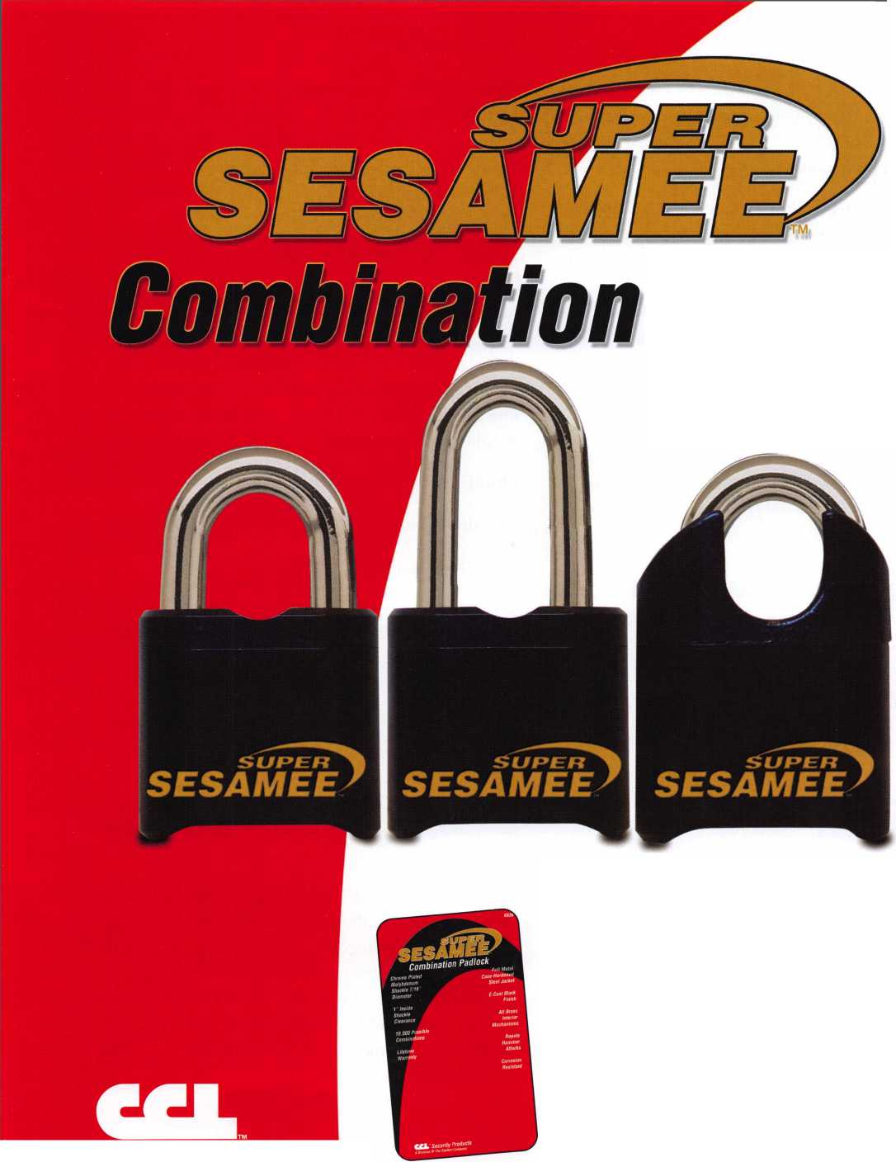
if, for example, your chair hurts your back, or you have insufficient light.
Do you have a filing system in place? Are price lists handy, forms readily available? Are templates organized so that you can access them quickly?
Whatever happened to the paperless office? The appearance of the computer was supposed to remove the need for paper. We can often be overwhelmed by paperwork. To avoid this, we need to develop techniques for efficiently handling paperwork. If you are to avoid drowning in a sea of paper, you need a straightforward and efficient technique for managing it along with document retrieval.
The physical organization of your working environment has a direct effect on your time-effectiveness. Take a good look at where you work. Don’t postpone taking action on any aspect of your workplace that you can change for the better.
TECHNOLOGY
You lead a busy and complex working life, and technology has a central role. Technology makes it possible for us to be more efficient—get more done—in many different ways. But we need to make sure that we are really controlling the technology so that it also helps us to be more effective— getting the right things done, rather than allowing it to control us. Technology will not organize your life for you. But it can be of great assistance. Learn as much as you can about the newest industry-related technologies and how it can help you.
PREPARATION
You have to meet with team members at the start of a new project, you have to make an important telephone call to a customer and you have a regularly scheduled meeting the same day. What will you do? How you prepare for these events is the key to participating in them in a time-efficient manner. Preparation is the key to saving time. Advance preparation for your hectic day can yield major benefits.
TIME STEALERS
There are many “time stealers”. Demands and interruptions from bosses, peers, or customers can prevent you from achieving your goals, and these must be dealt with appropriately. Not all time thieves are external. Most of us are prone to some degree of procrastination, and this can be the biggest time waster of all.
Procrastination is the thief of time. When you delay actions or a decision that you should be taking, its your time that is being stolen. Do you find excuses for putting off or completing things that you know you should be doing? If you are faced with something you need to do, but keep putting it off, try taking three small actions immediately. These actions may replace the temptation to or habit of procrastination.
Identify the outcome you want
Take the first step
Learn from the past
Practice makes perfect. Whenever you catch yourself postponing or delaying, take the action to move you toward your objective without further loss of time.
It is possible to be working hard, without working productively. Doing a task for a co-worker may seem to be the most efficient means to get a job done. But could you spend time teaching the co-worker a skill, so that they could handle it without you the next time? Sometimes just “getting the job done” will not be the best long-term solution.
Our time is important. Time management should not be a separate activity—it should be a fundamental part of the daily way you do things. For this to happen, you need to be able to develop good time management habits and avoid bad ones. An effective use of time also involves managing your environment, harnessing your use of technology, advanced preparation and recognizing and controlling time-wasting.
26
Keynotes • January 2006

Ilco’s “You Could Win
a Trip to Vegas and
Ultimate Lockshop Package”
^ I ^

Sweepstakes

www.kaba-ilco.com/vanpromo
for all the details!
Sweepstakes is open to all professional Locksmiths & Security personnel, located in the 50 U.S., the District of Columbia & Canada (except for Quebec), who have an account with an authorized Hco Products Distributor, who are eligible to make purchases of qualifying llco parts from authorized llco Distributors & who are 21 years of age or older as of 5/24/06. Void in Quebec & where prohibited by law. No purchase necessary. For the Official Rules & for an Official Entry Form, log on to www.kaba-ilco.com/vanpromo, or see your llco Products Distributor. Mail entries to: llco “You Could Win A Trip To Vegas & Ultimate Lockshop Package” Sweepstakes, P.O. Box 222510, Hollywood, FL 33022-2510. Entries must be postmarked by 5/17/06 and rec’d by 5/24/06.
A Member of the KABA Group
www.kaba-ilco.com
KAKA
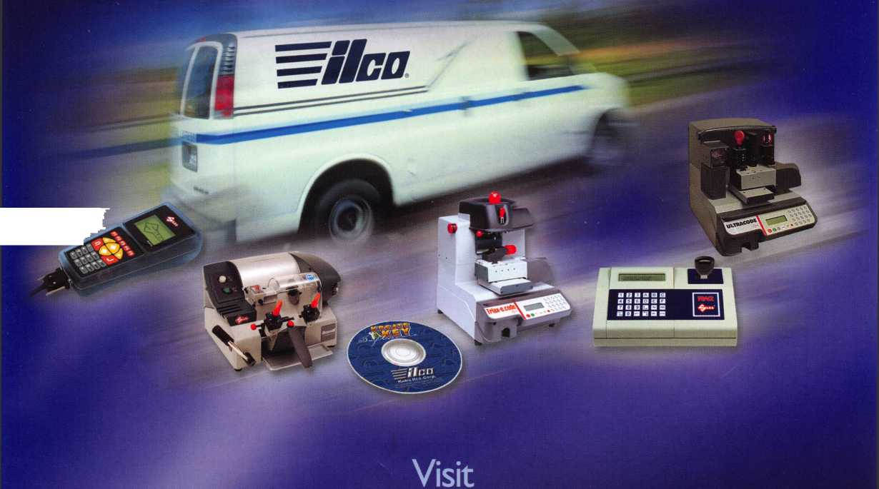
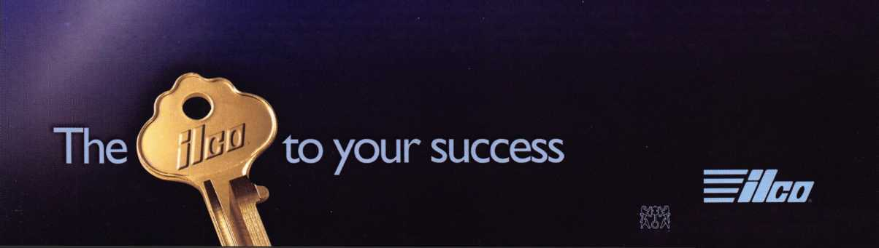

The BF and the Convertible Gun Safes
by: Greg Perry, CML, CPS
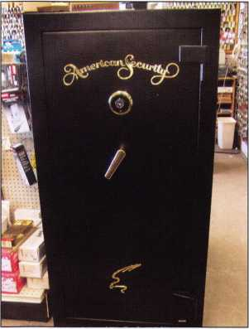
This is the safe with the S&G dial and lock installed.
Amsec recently intro-
duced a new line of gun
safes, the BF series. At
the same time, they
redesigned the
LP6032W. When I first
saw these products at the
2005 ALOA Convention
and Security Expo in
Chicago, I was
impressed! The new BF
series comes with a
poured fill of insulating
material like most fire
safes. This provides a
better fire rating than
gun safes that use the
more common gypsum-
board liners and the
price is competitive with
most other
brands. In addi-
tion, they pro-
vide decent bur-
glary protec-
tion, unlike that
which common
fire safes offer
with sheet
metal boxes.
Real fire safes
are designed
and tested to
keep the inter-
nal temperature
of the safe
under 350
degrees with an
outside temperature of 1800 degrees for at least one hour. Most gun safes with lined gypsum board get tested for 1200 degrees for 30 minutes. The BF gun safe line is tested to 1275 degrees for 90 minutes. A decent house fire can reach 1500
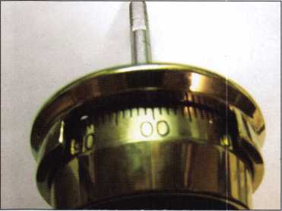
Photo 2 shows the original Amsec dial. Note that the dial starts at 00. All the current S&G dials start at 0, this is a quick way to tell which lock is installed.
degrees at the ceiling in 15 minutes so if your gun safe is near the point of ignition, chances are it will not provide enough protection. On the other hand, depending on where the safe is located in relation to the fire, the additional protection could make the difference between a happy customer and a total loss.
Also displayed Sitting next to the BF units at the show was an LP6032W. My first comment was “nice price” and it does looks nice but it comes with a direct entry lock. The number of combinations changes available on the this lock is very limited, however. The question also arises, “What if the customer wants a mechanical or an electronic lock upgrade?” The answer to this question might surprise you as it did me; there is a nice surprise inside. The door is drilled inside for the direct entry lock (a square hole pattern) but it is also drilled for the more common rectangular footprint safe lock (more commonly referred to as a Group 2 footprint). The outside face is also drilled for both dial-ring hole patterns. The bolt bar has an extension installed for use with the direct-entry lock or a notch in the appropriate location for the lock bolt of a mechanical or electronic lock or standard safe lock. The only thing lacking in this safe is an internal relock and/or and external relocker (either internal to the lock or external). Changing to a Group 2 mechanical lock or an electronic lock will add the internal relock. Punching the spindle of the direct-entry lock will not allow the safe to open. In both cases, the lock would need to be punched off the door to gain entry. Perhaps I worry too much.
This safe has had 3 different locks installed on it in just a couple of months. The first lock from the factory is the direct-entry lock seen in photos 1 through 3. Next, in photos 4 and 5, we installed an S&G 6741 removed from a different gun safe that we upgraded to an electronic lock. This allowed us to set the standard combination we use at our shop for display safes. As luck would have it, when this safe was sold, the customer wanted an electronic lock.
It was then time to change out the lock it again. This time, we installed a Globalok ULIX-1 from Millennium Lock Corp. This lock is simple to install (after removing the old lock) as you can see in photos 6 through 10.
Keynotes • January 2006

The process is simple. After removing the old lock, insert the plastic cable protector into the spindle hole, flush with the outside face of the door. Then, mark the tube flush with the inside door face and cut to length.
The keypad is next. Plug in the batteries, (the cable from the battery compartment is hidden behind the circuitboard of the keypad). Find the keypad to lock cable. Plug one end of the cable onto the keypad connector. Insert the cable through the spindle hole and using the two socket-head cap screws provided, attach the keypad to the door.
Finger-tighten the screws at this point. Next, insert the plastic tube in the spindle hole. Insert the hole-end of the spindle into the turn knob and push the small retaining pin through the hole in the turn knob. Insert the pin through the keypad and mark the spindle at 7/8”, sticking through the back of the safe door. Remove and cut to length. Deburr it and reinstall it in the keypad. Carefully route the cable on the inside of the door and install the lock body. Plug the cable into the lock body and the keypad should beep and LEDs will flash. Reprogram the program code and the lock is ready to operate.
These gun safes are well built and should last your customer a lifetime. The BF safe should provide your customer with a good degree of fire protection. I like the ability this decent- quality low-end safe provides to upgrades.
Photo 3 is a close up of the six holes in the door
for mounting the dial ring. The four outer holes are
for the original lock. The 2 inner holes are the |  | s A*
standard mounting pattern.
Photo 4 takes us inside for
a view of the direct entry
lock. The only way to
change the combination
on this lock is to move the
connecting piece from the
dial spindle to the lock 180
degrees or disassemble
the wheel pack and turn
the wheels over. A better
idea is to order a new
wheel pack or install a
group 2 footprint lock.
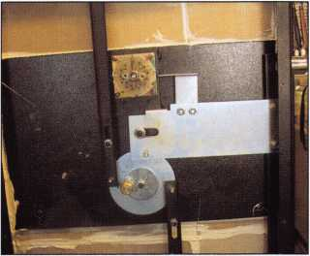
43rd ANNUAL CONVENTION & TRADE SHOW
The 2006 Texas Locksmith Conference and Trade Show
Doral Tesoro Hotel in Ft. Worth, Texas
February' | CD  O  o  CM  CM  1
• FREE CLINICS | ■ ELECTION & INSTALLATION OF NEW OFFICERS
■ FREE SEMINARS | ■ PRODUCT EXHIBIT
■ GENERAL MEMBERSHIP MEETING | ■SCHOLARSHIP RAFFLE ■ BANQUET DINNER
OR CONFERENCE OR TRADE SHOW INFO CONTACT:  Troy Maynard, Secretary  Texas Locksmiths Association  RO. Box 342  Dripping Springs, TX 78620  Phone: 512-264-0279 • Fax: 512-264-3060  Email: sec@texaslocksmiths.org | FOR HOTEL RESERVATIONS CONTACT:  1-866-33-DORAL  Doral Tesoro Hotel & Golf Club  3300 Championship Parkway  Ft. Worth, TX 76177  Phone: 817-961-0800 • Fax: 817-961-0900
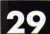
Keynotes • January 2006

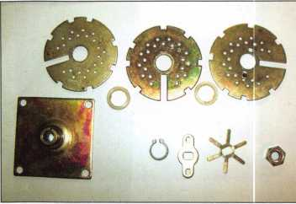
Photo 5 shows the original wheel pack disassembled. Note that the wheels are identical, the difference or what the combination is set to per wheel is where the drive pin is installed.
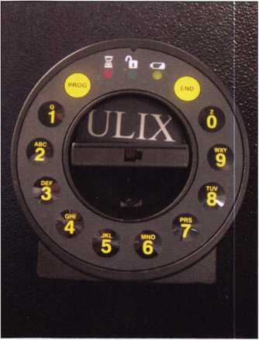
Photo 6 shows the inside lock mounting plate, here again note the two different sets of holes. The square set is for the original lock.
Photo 7 shows the door with an S&G 6741, this lock was pulled off a previous electronic upgrade.
Photo 8 is the ULIX keypad.
Photo 9 shows the cable and spindle sticking Photo 10 shows the ULIX lock body installed,
through the door.
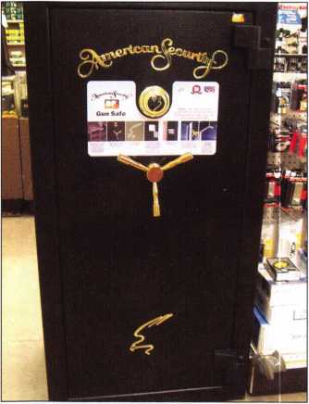
Photo 11 is the other new safe from Amsec, the BF gun safe.
Keynotes • January 2006
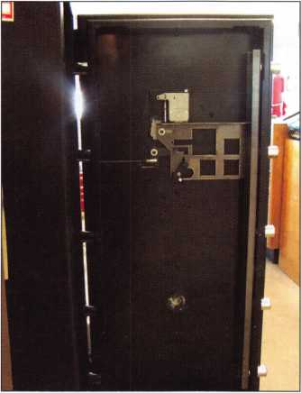
Photo 12 shows a very common boltwork configuration from Amsec. Lock is mounted vertical down with a relock next to the lock body.
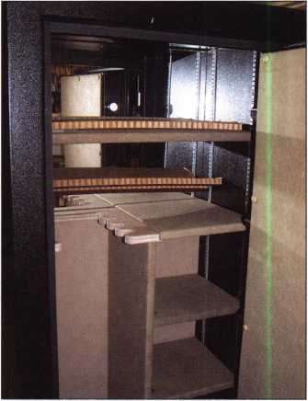
Photo 13 shows a little of the interior. Amsec has installed a mirror on the back wall to provide a better view of the interior. It also limits the ability to install a lag screw through the back wall for anchoring the safe, a method we have used in the past for extra security. But, Amsec does provide four holes in the bottom of the safe for anchoring.
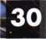
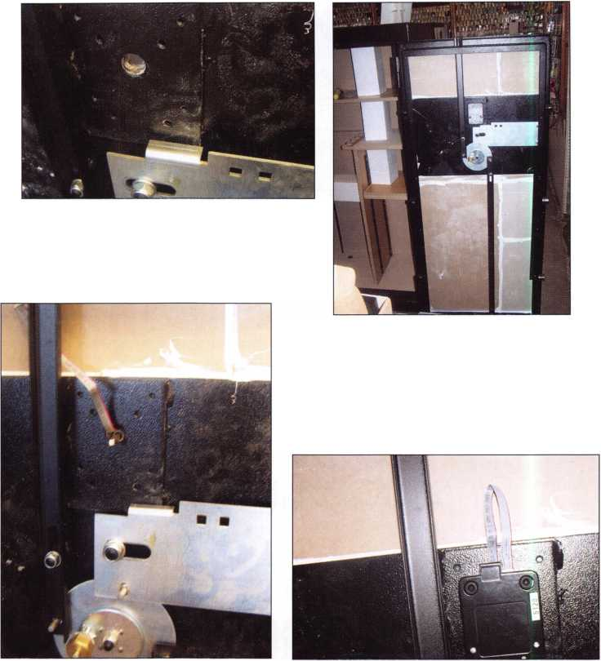

Part #692931
INNOVATIVE DESIGN
The offset position of the transponder in the head of the key maximizes the RFID signal strength by placing it closer to the ignition signal.
MING SOON! CADILLAC, PONTIAC AND BUICK VERSIONS.
>
Part #708884
GD (D® @®d
®Q0
ffifflR
• Designed to transmit a stronger RFID signal for better overall performance

General Motors Trademarks are used under license to STRATTEC Security Corporation
CODE-SEEKER™
NOT JUST A TOOL, A MONEY-MAKING MACHINE.
FEATURE-FILLED!
Easy to use, quickly connecting to the OBD port • Includes all cables and connectors Adds, erases and programs keys Program RKE fobs (selected models)
- Obtains immobilizer code for certain models
- Fully upgradeable
- Expandable database
ORDER YOUR MONEY-MAKING MACHINE TODAY.
Leasing Options Available. Contact your local distributor today.
3333 WEST GOOD HOPE ROAD
http://afterinarket.strattec.com
MILWAUKEE, Wl 53209
877.251.8798
TM
TRUSTED SOURCE. MANY SOLUTIONS.
Now Available
2006 GENERAL MOTORS TRANSPONDER KEYS
®2005 STRATTEC SECURITY CORPORATION, ALL RIGHTS RESERVED,
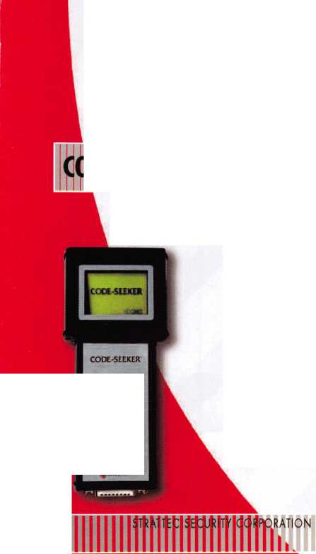
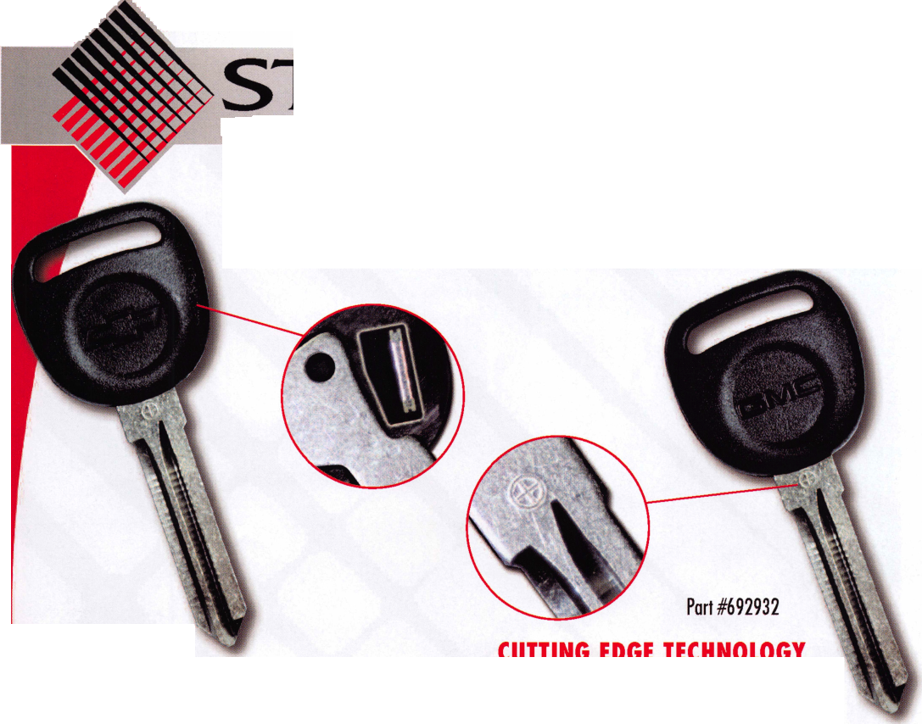
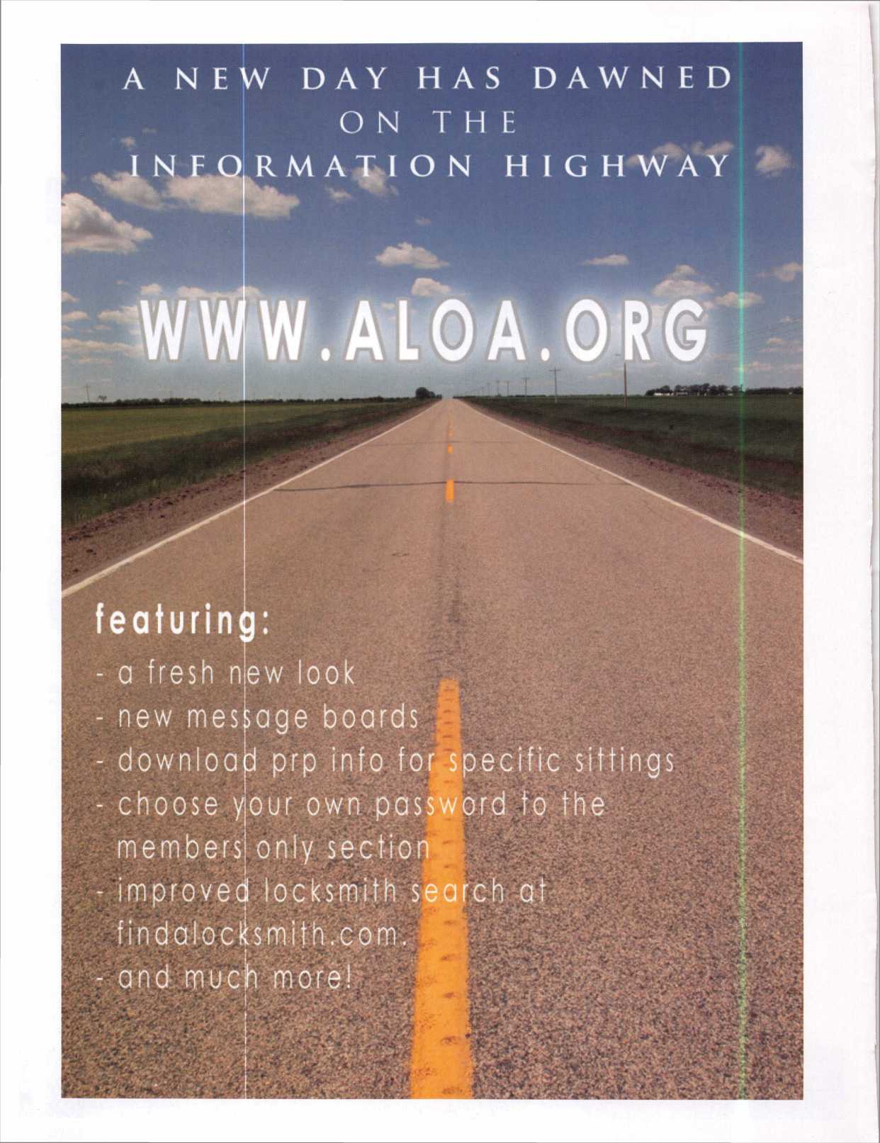

Hardwiring Made Easy
Make the perfect connection every
time with SARGENTS ElectroLynx.
The plug-in universal connectors and
the easy, color-coded wire system
eliminates matching wires. Wiring is a
snap and completely fool-proof.
SARGENT
Look for the LYNX
ELECTROi
As part of their promise to provide innovative, fast and effective, and higher security solutions to their customers, ASSA ABLOY Group
companies offer ElectroLynx, a universal quick-connect system that simplifies the electrification of the door opening.
Dugmore introduces NEW Memphis, TN location.
Dugmore & Duncan is committed to getting our products to
our customers ASAP. Our research revealed that Memphis
TN has an innovative business plan to make the most of its
strategic location and natural resources. It is a multi-carrier
transportation hub.
D&D has consolidated a substantial amount of its warehouse
inventory into a prime Memphis location. In addition to our
current strategic points of distribution, Dugmore delivers from
Memphis. We are confident that this is a great opportunity for
Dugmore and for our loyal customers.
DUGMORE
DUNCAN
Securing Your World
Distributor of
SARGENT
Products
Call (888) 384-6673
FAX (888) 329-3846 • www.dugmore.com
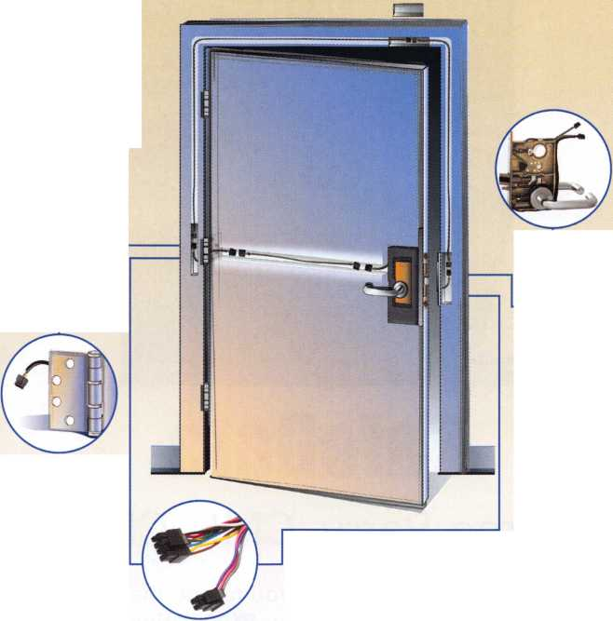
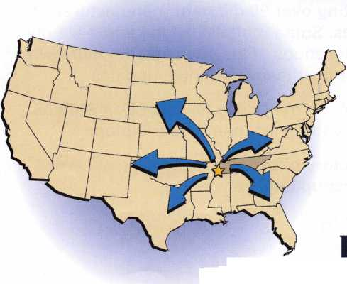

Email: glmperry@iwuisp.com for unlock code Greg perry 2003
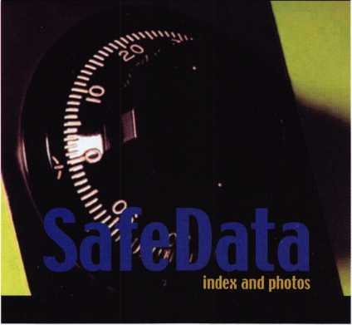

SafeData
Greg Perry, CML, CPS
Open up your library! SafeData allows you to find the information you've
invested in, fast.This one program has over 8500 listings of magazine, books,
ClearStar Security Network posts and my personal library. Each listing includes not
only the book or magazine, the issue, the title, the author and the page, but it also
lists the lock and the hand of the lock (when available). SafeData lists patent dates
and other trivia that may help in identifying a container or lock.
SafeData also has picture folders representing over 90 different manufactures of
safes and locks with over a thousand pictures. Some models include a text file giv-
ing general information on size and relock locations. Plus you can add your own
information and update it yourself or purchase the annual updates.
SafeData is available exclusively from ALOA. Normal price for this CD is $249.95.
Price includes two installs! Put it on your desktop and your laptop.
Special Introductory offer
includes your first update!
$199.95
To order contact ALOA (800) 532-2562

New Tools: Low Cost Bench Top

Peen Marking System
Just hook the system up to a PC, load the software, connect an air line and it’s ready to go...
Keynotes • January 2006

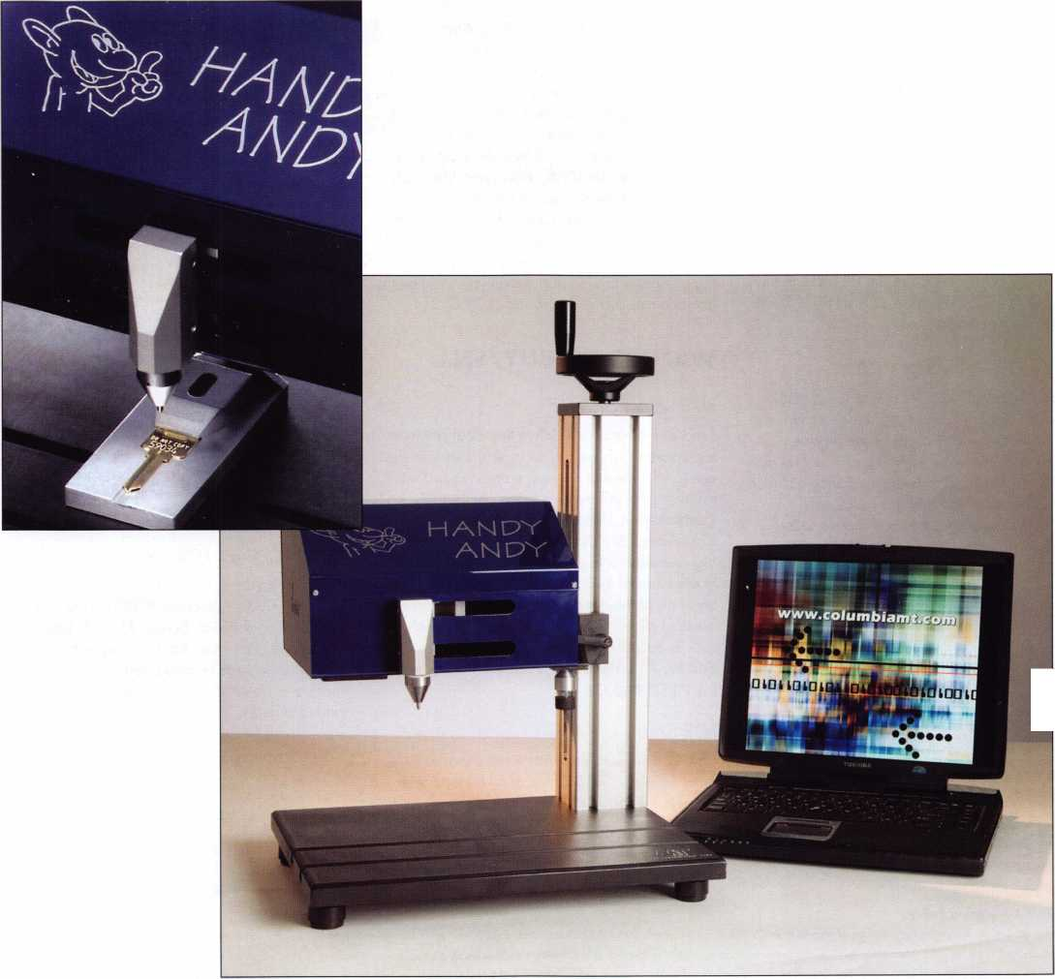

Classifieds
EMPLOYMENT
ACCESS CONTROL TECHNICIAN NEEDED
He/she must have 3-4 years experience in Sales & Installation of Electronic access control & cctv Installation & Service. Contact Denny Birt 1-800- 352-5034
LOCKSMITH WANTED
Busy shop in Woburn Massachusetts seeks experienced locksmiths for Auto, Commercial, Residential, Safe and Card Access work. We have a large AAA area which we cover and do transponder and high security keys. Will help train in fields you are not familiar with. Sub contractors welcome or we will supply tools and van. Great opportunity for self-motivated individual. Please sign up to join our team. Call John at 781-933-9999 or send resume to: Locks & Keys, Inc., PO Box 222, Woburn, MA 01 801. Thank you for your consideration.
LIVE, WORK & PLAY IN HAWAII
Locksmith Service Technician needed for 25- year-old company in HAWAII. Need knowledge and experience in all areas of locksmithing. Wages commensurate with experience and abilities. Great health and dental insurance and benefits. Late model van and tools provided.
Mail resume to: Paradise Lock & Safe, 350 Ward Ave., Suite 106-417, Honolulu, HI. 96814-4004.
EXPERIENCED LOCKSMITH WANTED
Charlottesville, VA is seeking an experienced locksmith. For information, please e-mail: snowderrow@aol.com or fax resume to 434-971-8021. Phone 434-977-5397.
EXPERIENCED LOCKSMITH WANTED
Nationwide Security & Building Services, Inc. (NSBS) has been in business for over 30 years and is an established leader in the security
industry. In addition to providing all aspects of locksmith and security services, we also provide complete facility maintenance. We are in need of experienced and motivated locksmiths who take pride in their work. We currently have an opening for a locksmith technician working out of our Downey, CA, San Diego, CA, Phoenix,
AZ and Irving, TX locations. A qualified candidate must have minimum 2 years commercial locksmith experience, excellent communication skills, a good driving record and some computer skills. Safe opening, skills in electrical, lighting, drywall, doors and gates are a plus. Benefits of being employed by NSBS include: paid vacation / holidays, medical, dental and life insurance, competitive wages, 401k plan, company truck and all tools are supplied, fun atmosphere with career growth. If you feel you are qualified and are looking for a challenging and rewarding company to work for, e-mail your resume to dawnu@nsbs.net or fax to (562) 299-151 1.
WANTED TO BUY/SELL
BUSINESS FOR SALE
Tired of the rat race? Here's the ideal situation for someone who wants to raise a family in the upper Mid-West or seeks a more civilized environment and still make a living comfortably. Established in 1980, we specialize in Commercial & Institutional accounts with CCTV, high security locks and access control systems.
In the heart of Wisconsin with excellent hospital and one of the nation's largest privately owned medical clinics. Contact Robert M. Dennee', Ace Lock & Security, PO Box 632, Marshfield, Wl 54449, 715-387-3064, rdennee@tznet.com, fax 715-389-8036.
FOR SALE
One Collier night depository self encased in steel, like new. TL15 Chest and UL Head with 25 keys - $3500.00. One class two vault door in good condition - $2500.00. One used 1073
diebold drive up ATM - make an offer. Many used safes please call for sizes and prices.
Buyer pays for crating and freight. Contact: Thistle Safe and Lock Co., Inc., 198 Cross St., Malden, MA 02148, 781-324-1600, thistlesnl@aol.com
NORTHERN CA BUSINESS FOR SALE
You now have the unique opportunity to purchase an established lock and safe business (1958) and clientele in a fast growing college town (Chico, CA), and possibly the plaza that houses the shop. Owner is looking to retire and owns both. We have great licensed employees, three vans, and a fully stocked shop. Please fax your references and letter of interest to: Johnny's Lock & Safe 530-873-3577.
FOR SALE
Framon II code machine, never used. Asking $1,500.00. Telephone: 610-698-8040,
Email :Foxlocknkey@aol.com
MOBILE LOCKSMITH BUSINESS FOR SALE
Central California Locksmith Business established in 1999 and still growing. Includes van, tools, equipment, code machine, inventory. Commercial, residential and automotive accounts. Located in Fresno, CA. $50,000. Ask for Noa Kristi 559-447-5397
KEY MACHINES FOR SALE
HPC 1200, Abloy, KD-55 High Security, Fitmaster, Curtis Automatic #2000, Scotsman #747-X, Sager #500, Borkey #954-2, llco Duplicon #2585, Keil #6 1/2, Segal #815, Belsaw, 2 Schlage double-sided key punches. Phone Jerry at 208-461-4606 or email: mariemeilan@yc2.net
Classified Advertising Policy
Classified advertising space is provided free of charge to ALOA members and for a fee of $2.00 per word, $40.00 minimum for non members. Classified ads may be used to advertise used merchandise and overstocked items for sale, "wanted to buy" items, business opportunities, employment opportunities/positions wanted and the like. Members or non members wishing to advertise services or new merchandise for sale may purchase a "Commercial Classified Ad" for a fee of $4.00 per word with a minimum of $100.00. Each ad will run for two issues. For blind boxes there is a $10.00 charge for members and non members. All ads must be submitted in writing to the Advertising Sales Department via fax at 817-645-7599 or through an email to adsales@aloa.org by the fifteenth of the month two months prior to issue date. ALOA reserves the right to refuse any classified advertisement that it deems inappropriate according to the stated purpose of the classified advertising section.

Columbia Marking Tools and partner, J.R. Richter of Germany, are introducing a new compact, cost-effective solution for making high quality dot peen marks on steel, aluminum, brass and plastic keys and locks sets. Called the “Handy Andy™”, this pneumatic bench-top marker has been designed for use by locksmiths who require the flexibility of a programmable marker at an investment that is half the cost of most lower-end conventional programmable marking machines.
Fully programmable, the Handy Andy can automatically apply serial numbering, date codes, job numbers, lot numbers, even logos. The PC software works with Windows® 95/98/2000/NT4/XP and is easy to understand and operate. Simple pull-down menus, icons, hot keys, text orientation control and point and click features minimize training time.
The marker unit is compact, measuring only 9.85 x 10.25 x 6.3-inches. A two-axis stepper motor, connected to the PC by a serial interface, connection controls the dot peen marking stylus. Pneumatic dot peen force is 14.5 psi maximum, which allows for marking fragile parts. The Handy Andy marking unit and software can be purchased for $3,000.
Optional features include a 10 x 10-inch table with a vertical height-adjustable post that mounts the marking unit. Vertical height adjustment is up to 7.9-inches.
Columbia Marking Tools is a leading designer and manufacturer of metal and plastic marking equipment including stamps, roll marking dies, roll marking and impact marking machines, fully programmable peen/scribe marking and UID/2DMatrix™ marking systems, numbering heads and special marking machines.

‘ TO YOU

Need information in a hurry? Use ALOA’s
FaxOn Demand service.
Just call 310-575-5074 and receive:
- ALOA Index of Documents
- Becoming a Locksmith (Ipg)
- Locksmith Career Summary (3pg)
- Locksmith School List (2pg)
- ACE Class Schedule (8pg)
- Certification lnformation(3pg)
- PRP Category List (Ipg)
- ALOA Membership Application(2pg)
S
9. ALOA List of Benefits (Ipg)
10. Scholarship Application Form (Ipg)
11. ALOA Video Library Order Form (Ipg)
I 12. ALOA Membership Items Order Form (Ipg)
§| 13. Safe & Vault Technicians Association Member
Application/Subscription Form (2pg)
| 14. ALOA Chapter Roster (3pg)
I 15. Legislative Action Network (2pg)
f 16. Legislative Action Network Newsletters (Ipg)
mm 17. Various State Laws (10pg)
1 18. Industry Position Pager (Ipg)
I 19. Current Legislative Action Network
Newsletters (Ipg)
I 20. Board of Directors Nomination Form (2pg)
1 21. ALOA Convention Registration
i 22. ALOA Board Expense Reimbursement &
Request Form
310-575-5074

Keynotes • January 2006
3
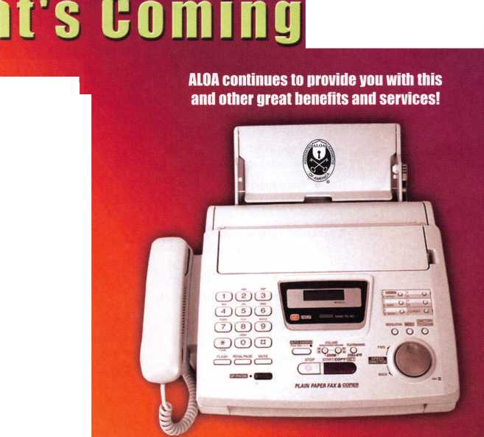
associate
members
Distributor
- st In Hardware, Inc.
Phone: Phone: 410-646-9900 Fax: 410-646-0045 www. 1 stinhardware.com
Accredited Lock Supply Co.
Phone: 800-652-2835 Fax: 201-865-0030 www.acclock.com
Andrews Wholesale Lock Supply
Phone: 717-272-7422 Fax: 717-274-8659 www.andrewslock.com
Boyle & Chase Inc.
Phone: 800-325-2530 Fax: 800-205-3500 www.boyleandchase.com
Clark Security Products
Phone: 888-784-131 1 Fax: 619-718-7333 www.clarksecurity.com
Cook's Building Specialties
Phone: 505-883-5701 Fax: 505-883-5704
Dire's Lock & Key Company
Phone: 303-294-0176 Fax: 303-294-0198
Direct Security Supply, Inc.
Phone: 800-252-5757 Fax: 800-452-8600
Discount Key Machines.Com/Busch
Phone: 800-332-8724 Fax: 407-363-4666
Doyle Security Products
Phone: 800-333-6953 Fax: 612-521-0166 www.doylesecurity.com
Dugmore and Duncan, Inc.
Phone: 888-384-6673 Fax: 888-329-3846
E. L. Reinhardt Co., Inc.
Phone: 800-328-131 1 Fax: 651-481-0166 www.elreinhardt.com
Ewert Wholesale Hardware
Phone: 800-451-0200 Fax: 708-597-0881
Foley-Beisaw Company
Phone: 800-821-3452 Fax: 816-483-5010 www.foley-belsaw.com
Fried Brothers Inc.
Phone: 800-523-2924 Fax: 215-592-1255 www.fbisecurity.com
Hans Johnsen Company
Phone: 214-879-1550 Fax: 214-879-1530 www.hjc.com
Hardware Agencies, Ltd.
Phone: 416-462-1921 www.hardwareagencies.com
IDN Incorporated
Phone: 817-421-5470 Fax: 817-421-5468 www.idn-inc.com
Instant Hardware Delivery, Inc
Phone: 800-355-1107 Fax: 800-663-8518
Intermountain Lock & Supply
Phone: 800-453-5386 Fax: 801-485-7205 www.intermountainlock.com
International Electronics, Inc
Phone: 800-343-9502 Fax: 617-821-4443
Jo Van Distributors
Phone: 416-288-6306
Fax:416-752-8371
www.jovanlock.com
Lockmasters, Inc.
Phone: 859-885-6041 Fax: 859-885-7093 www.lockmasters.com
Locks Company
Phone: 800-288-0801 Fax: 305-949-3619
Locksmith Ledger International
Phone: 770-886-0800 Fax: 770-889-7703 www.lledger.com
McDonald Dash Locksmith Supply
Phone: 800-238-7541 Fax: 901-366-0005 www.mcdonalddash.com
Monaco Lock Co.
Phone: 800-526-6094 Fax: 800-845-5625 www.monacolock.com
Omaha Wholesale Hardware
Phone: 800-238-4566 Fax: 402-444-1664 www.omahawh.com
Phoenix Safe International LLC
Phone: 765-483-0954 Fax: 765-483-0962 www. phoen ixsafeusa .com
RA-Lock Company
Phone: 972-775-6301 Fax: 972-775-6316 www.ralock.com
Security Distributors Inc
Phone: 800-333-6953 Fax: 612-524-0166
Security House
Phone: 905-669-5300 Fax: 905-660-6313 www.securityhouselock.com
Security Lock Distributors
Phone: 800-847-5625
Fax: 800-878-6400
www.securitylockdistributors.com
Southern Lock and Supply Co.
Phone: 727-541-5536 Fax: 727-544-8278 www.southernlock.com
Stone & Berg Wholesale
Phone: 800-225-7405 Fax: 800-535-5625
The Locksmith Store Inc.
Phone: 847-364-51 1 1 Fax: 847-364-5125 www.locksmithstore.com
Timemaster Inc.
Phone: 859-259-1 878 Fax: 859-255-0298 www.time-master.com
Top Notch Distributors, Inc.
Phone: 800-233-4210 Fax: 800-854-4146 www.topnotch.bz
Turn 10 Wholesale
Phone: 800-848-9790 Fax: 800-391-4553
U.S. Lock Corp.
Phone: 800-925-5000 Fax: 800-338-5625 www.uslock.com
Wilson Safe Company
Phone: 215-492-7100 Fax: 215-492-7104 www.wilsonsafe.com
Manufacturer
A & B Safe Corporation
Phone: 800-253-1267 Fax: 856-863-1208 www.a-bsafecorp.com
ABUS Lock Company
Phone: 800-352-2287 Fax: 602-516-9934 www.abus.com
Access Security Products Ltd.
Phone: 905-337-7874 Fax: 905-337-7873 www.access-safe.com
Adams Rite Mfg Company
Phone: 800-872-3267 Fax: 800-232-7329 www.adamsrite.com
Adesco Safe Mfg. Company
Phone: 800-694-9340 Fax: 562-408-6427 www.adesco.com
Adrian Steel Company
Phone: 800-677-2726 Fax: 517-265-5834 www.adriansteel.com
Advanced Diagnostics USA Inc
Phone: 650-876-2020 Fax: 650-876-2022 www.ad-mvp.com
All Five Tool Company, Inc.
Phone: 860-583-1691 Fax: 860-583-4516 www.all5tool.com
American Security Products
Phone: 909-685-9680x2013 Fax: 909-685-9685 www.amsecusa.com
BWD Lockcraft
Phone: 973-728-3707 Fax: 973-728-3731 www.bwdautomotive.com
Bianchi USA, Inc.
Phone: 800-891-2118 Fax: 216-803-0202
Buddy Products
Phone: 312-733-6400 Fax: 312-733-8356 www.buddyproducts.com
CCL Security Products
Phone: 800-733-8588 Fax: 847-537-1 800 www.cclsecurity.com
Keynotes • January 2006

a | s s o c i a 1 | \ e
 | members
CompX Security Products | KEY-BAK/West Coast Chain Mfg. | ROFU International Corp. | Videx Inc.
Phone: 864-297-6655 | Phone: 909-923-7800 | Phone: 253-922-1828 | Phone: 541-758-0521
Fax: 864-297-9987 | Fax: 909-923-0024 | Fax: 253-922-1728 | Fax: 541-752-5285
www.compxnet.com | www.keybak.com | www.rofu.com | www.videx.com
D&D Technologies (USA), Inc. | Keri Systems Inc. | Rutherford Controls Inti Co. | YSG Door Security
Phone: 714-677-1300x292 | Phone: 408-451-2520 | Phone: 519-621-7651 | Consultants, Inc.
Fax: 714-677-1299 | Fax: 408-441-0309 | Fax:519-621-7939 | Phone: 800-438-1951
www.ddtechusa.com | www.kerisys.com | www.rutherfordcontrols.com | Fax: 800-338-0965
DETEX Corp. | Knaack Manufacturing Co. | STRATTEC Security Corp.
Phone: 800-729-3839 | Phone: 800-456-7865 | Phone: 414-247-3333 | Service
Fax: 830-620-6711 | Fax: 815-459-9097 | Fax: 414-247-3564
www.detex.com | www.weatherguard.com | www.aftermarket.strattec.com | Organization
Don~Jo Manufacturing, Inc. | LAB Security | Sargent & Greenleaf, Inc.
Phone: 978-422-3213 | Phone: 800-243-8242 | Phone: 859-885-9411 | Allstate Insurance Company
Fax: 978-422-3467 | Fax: 860-583-7838 | Fax: 859-885-3063 | Phone: 800-859-0247
www.don-jo.com | www.labpins.com | www.sargentandgreenleaf.com | Fax: 847-551-2786 www.allstate.com
Door Controls International | La Gard Inc. | Sargent Manufacturing Co.
Phone: 800-742-3634 | Phone: 310-325-5670 | Phone: 800-727-5477 | Cross Country Automotive
Fax: 800-742-0410 | Fax: 310-325-5615 | Fax: 888-863-5054 | Services
www.doorcontrols.com | www.lagard.com  Lock America, Inc. | www.sargentlock.com | Phone: 800-541-2262  Fax: 781-393-0256
Doorking Inc* |  | Schwab Corp. | www.argosi.com
Phone: 800-826-7493 | dba L.A.I. Group | Phone: 765-447-9470
Fax: 310-641-1586 | Phone: 714-373-2993 | Fax: 765-447-8278 | Massglass & Door Service
www.doorking.com | Fax: 714-373-2998 | www.schwabcorp.com | Phone: 888-742-8837
FireKing Security Products | www.laigroup.com | Securifort Inc | Fax: 845-735-8383 www.mechanicgroup.com
Phone: 800-457-2424 | Lucky Line Products, Inc. | Phone: 819-359-2226
Fax: 800-896-6606 www.fkisecuritygroup.com | Phone: 858-549-6699  Fax: 858-549-3241 | Fax: 819-359-2218 www.securifort.com | The Mechanic Group Inc  Phone: 845-735-0700
Framon Manufacturing | www.luckyline.com | Securitron Magnalock Corp. | Fax: 805-497-2255
Company Inc. | M.A.G. Manufacturing | Phone: 775-355-5625 | www.massglass.com
Phone: 989-354-5623 | Phone: 714-891-5100 | Fax: 775-355-5636 | Webster Safe & Lock Co., Inc,
Fax: 989-354-4238 | Fax: 714-892-6845 | www.securitron.com | Phone: 901-332-2911
www.framon.com | www.magmanufacturing.com | Security Door Controls | Fax: 901-332-2878
HY-KO Products Co. | MUL-T-LOCK USA, Inc. | Phone: 805-494-0622 | www.webstersinc.com
Phone: 330-467-7446 | Phone: 800-562-3511 | Fax: 805-494-8861
Fax: 330-467-7442 | Fax: 973-778-4007 | www.sdcsecurity.com
Hammerhead Industries, Inc. | www.mul-t-lockusa.com | Security Solutions
Phone: 805-658-9922 | Major Mfg, Inc. | Phone: 405-376-1600
Fax: 805-658-8833 | Phone: 714-772-5202 | Fax: 405-376-6870
www.gearkeeper.com | Fax: 714-772-2302 | www.securitysolutions-usa.com
Ingersol! Rand SSA | www.majormfg.com | Sun Safes Manufacturing Co.
Phone: 317-613-8025 | Maxcess Card Systems Ltd | Phone: 823-194-5930
Fax: 317-613-8068 | Phone: 949-492-5964 | Phone: 823-194-5940
www.schlagelock.com  Jackson Corporation | Fax: 949-492-0415 www. maxcess-ca rd.com | Townsteel, Inc.  Phone: 626-858-5080
Phone: 323-269-8111 | Medeco Security Locks | Fax: 626-858-3393
Fax: 800-888-6855 | Phone: 540-380-5000 | www.townsteel.com
www.jacksonexit.com | Fax: 540-380-5010 | UCA Inc
Jet Hardware Mfg., Co. | www.medeco.com | Phone: 972-312-0599x12
Phone: 718-257-9600 | Mil-Comm Products Co Inc | Fax: 972-692-7056
Fax: 718-257-0973 | Phone: 201-935-8561 | www.ibuttonlock.com
www.jetkeys.com | Fax: 201-935-6059
KABA ILCO Corp.  Phone: 252-446-3321 | Protex Safe Co., LLC  Phone: 818-610-8030 | Ultra Lift Corporation  Phone: 800-346-3057  Fax: 408-297-1199
Fax: 252-446-4702 | Fax: 818-610-8004 | www.ultralift.com
www.kaba-ilco.com | www.protexsafe.com
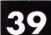
Keynotes • January 2006

US H 3632
SPONSOR: LaTourette (R|
TITLE: Electronic Premise Security Systems INTRODUCED:
07/29/2005
DISPOSITION: Pending
LOCATION: House Ways and Means
Committee
SUMMARY:
Allows a deduction for expenses related to the purchase and installation of qualifying electronic premise security systems.
STATUS:
- 07/29/2005 INTRODUCED.
- 07/29/2005 To HOUSE Committee on
WAYS AND MEANS.
CA A 714
AUTHOR: Ridley-Thomas |D]
TITLE: Motor Vehicles: Key Information Access INTRODUCED:
02/17/2005 LAST AMEND:
09/08/2005
DISPOSITION: Pending - Carryover LOCATION: Assembly Transportation Committee
SUMMARY: Requires every motor vehicle manufacturer of a motor vehicle sold or leased in this state with a model year of 2007 or later to provide a means whereby the registered owner of that motor vehicle can access information sufficient to permit the reproduction of a key to operate the owner's vehicle 24 hours each day and 7 days each week.
STATUS:
- 02/17/2005 INTRODUCED.
- 09/07/2005 To ASSEMBLY Committees on
TRANSPORTATION and BUSINESS AND PROFESSIONS.
- 09/08/2005 From ASSEMBLY Committee
on TRANSPORTATION with author's amendments.
- 09/08/2005 In ASSEMBLY. Read second
time and amended. Re-referred to Committee on TRANSPORTATION.
IN H 1361
AUTHOR: Brown C |D)
TITLE:Locksmith
Registration
INTRODUCED:
01/13/2005
DISPOSITION: Failed - Adjourned LOCATION: House Public Safety and Homeland Security
SUMMARY: Reauires locksmiths to be registered; requires the state police department to administer the registration program and conduct a national criminal history background check for each registration applicant.
STATUS:
- 01/13/2005 INTRODUCED.
- 01/13/2005 To HOUSE Committee on
PUBLIC SAFETY AND HOMELAND SECURITY.
NOTES:Locksmith Registration
MD H 207 CROSSFILED WITH:MD S 105
AUTHOR: Hubbard (D)
TITLE: Maryland Security Systems Training Board
INTRODUCED:
01/24/2005
DISPOSITION: Failed - Adjourned LOCATION:
HOUSE
SUMMARY: Establishes the Maryland Security Systems Training Board; requires the Secretary of State Police to adopt regulations to implement
training requirements for security systems technicians developed by the Maryland Security Systems Training Board; provides for the composition of the Board ana the terms, removal, and compensation of the members of the Board; authorizes the Board to set specified
fees; requires the Board to set training requirement.
STATUS:
- 01/24/2005 INTRODUCED.
- 01/24/2005 To HOUSE Committee on
ECONOMIC MAHERS.
- 02/21/2005 From HOUSE Committee on
ECONOMIC MAHERS: Reported unfavorably.
NOTES:Security Systems Training Board
MO S 186
SPONSOR: Loudon (R)
TITLE: Electrical Industry Licensing Board INTRODUCED: 01/18/2005 DISPOSITION: Failed - Adjourned LOCATION: Senate Financial and Governmental Organization, Veterans' Affairs and Elections Committee SUMMARY: Establishes the Missouri Electrical Industry Licensing Board and describes their powers and duties.
STATUS:
- 01/18/2005 INTRODUCED.
- 01/24/2005 To SENATE Committee on
FINANCIAL, GOVERNMENTAL ORGANIZATIONS, AND ELECTIONS.
NOTES:Electrical Industry Licensing Board
MS S 2356
AUTHOR: Mettetal (D)
TITLE: Burglar Alarms INTRODUCED: 01/13/2005 DISPOSITION: Failed LOCATION: Died
SUMMARY: Burglar alarms; license and regulate installation.
STATUS:
- 01/13/2005 INTRODUCED.
- 01/13/2005 To SENATE Committee on
BUSINESS AND FINANCIAL INSTITUTIONS.
- 02/01/2005 Died in
committee.
NOTES:Burglar Alarm License
NJ A 3943
IDENTICAL: NJ S 2337
SPONSOR: Johnson (D)
TITLE: Electronic Security Systems PREFILED: 03/14/2005 INTRODUCED:
05/02/2005
DISPOSITION: Pending
LOCATION: Assembly Regulated Professions
and Independent
Authorities Committee
SUMMARY: Exempts
certain businesses from licensing requirements for those engaged in burglar alarm, fire alarm and electronic security system installations.
STATUS:
- 03/14/2005 FILED.
- 05/02/2005 INTRODUCED.
- 05/02/2005 To ASSEMBLY
Committee on REGULATED PROFESSIONS AND
INDEPENDENT AUTHORITIES. NOTES:Electronic Security Systems
PA H 1653 PN: 2080
AUTHOR: Raymond (R)
TITLE: Vehicles Code PREFILED: 06/06/2005 INTRODUCED:
06/07/2005
DISPOSITION: Pending
LOCATION: House Transportation Committee
SUMMARY: Amends the Vehicles Code.
Provides for duplicate vehicle keys.
Prescribes a penalty.
STATUS:
- 06/06/2005 FILED.
- 06/07/2005 INTRODUCED.
- 06/07/2005 To HOUSE
Committee on TRANSPORTATION.
TN S
2024 SAME AS:
TN H 1731
AUTHOR: Cooper (D|
TITLE: Locksmith Licenses INTRODUCED:
02/16/2005
LAST AMEND: 04/28/2005 DISPOSITION: Pending - Carryover LOCATION:
HOUSE SUMMARY:
Requires locksmiths to be licensed; requires licenses to be obtained from the commissioner of commerce and insurance.
STATUS:
- 02/16/2005 INTRODUCED.
- 02/23/2005 To SENATE Committee on
GOVERNMENT OPERATIONS.
- 03/30/2005 From SENATE Committee on
GOVERNMENT OPERATIONS: Recommend passage.
- 04/28/2005 In SENATE. Amendment No.
- (SA0172) adopted on SENATE floor.
- 04/28/2005 In SENATE. Amendment No.
- (SA0173) adopted on SENATE floor.
- 04/28/2005 In SENATE. Amendment No.
- (SA0304) adopted on SENATE floor.
- 04/28/2005 In SENATE. Amendment No.
- (SA0407) adopted on SENATE floor.
- 04/28/2005 In SENATE. Amendment No.
- (SA0408) adopted on SENATE floor.
- 04/28/2005 In SENATE. Read third time.
Passed SENATE.
To HOUSE.
NOTES:Locksmith License.
TX H 2243
AUTHOR: Jackson (R)
TITLE: Regulation of Locksmiths and Locksmith Companies
INTRODUCED: 03/08/2005 LAST AMEND: 05/16/2005 ENACTED: 06/18/2005 DISPOSITION: Enacted LOCATION: Chaptered CHAPTER: 1102
SUMMARY: Relates to the regulation of lock-
smiths and locksmith companies under the
Private Security Act; provides that a locksmith
company or locksmith may not perform servic-
es for a customer who seeks entry to a struc-
ture, motor vehicle, or other property unless
the customer, shows the locksmith company or
locksmith a government-issued identification
and provides a signed authorization stating
that the customer or is entitled to legal access
to the structure, motor vehicle, or other prop-
erty.
STATUS:
- 03/08/2005 INTRODUCED.
- 03/14/2005 To HOUSE Committee on
LICENSING AND ADMINISTRATIVE PROCEDURES.
- 04/06/2005 From HOUSE Committee on
LICENSING AND ADMINISTRATIVE PROCEDURES: Reported favorably with substitute.
- 04/14/2005 Committee report printed
and distributed.
- 04/29/2005 Amended on HOUSE floor.
- 04/29/2005 Passed HOUSE.
To SENATE.
- 05/03/2005 To SENATE Committee on
BUSINESS AND COMMERCE.
- 05/16/2005 From SENATE Committee on
BUSINESS AND COMMERCE: Reported
favorably with substitute.
- 05/16/2005 Committee report printed
and distributed.
- 05/24/2005 Passed SENATE.
To HOUSE for concurrence.
- 05/26/2005HOUSE concurred in SENATE
amendments.
- 06/02/2005 To GOVERNOR.
- 06/18/2005 Signed by
GOVERNOR.
- 07/25/2005 Filed with Secretary of State.
Chapter No. 1102
NOTES Regulation of Locksmiths and Locksmith Companies
TX H 3140
AUTHOR: Hughes (R|
TITLE: Private Security Regulation INTRODUCED: 03/11/2005 LAST AMEND: 04/25/2005 ENACTED: 06/18/2005 DISPOSITION: Enacted LOCATION: Chaptered CHAPTER: 1155
SUMMARY: Relates to exemption of certain electronic access control device or alarm system manufacturers or providers from private security regulation; provides that an alarm system does not include a telephone entry system, operator for opening or closing a residential or commercial door or an accessory to activate a gate or door that is not connected to an alarm system; provides that an electronic access control device includes a telephone entry system into an area not monitored by security personnel.
STATUS:
- 03/11/2005 INTRODUCED.
- 03/21/2005 To HOUSE Committee on
LAW ENFORCEMENT.
- 04/25/2005 From HOUSE Committee on
LAW ENFORCEMENT: Reported favorably with substitute.
- 04/30/2005 Committee report printed
and distributed.
- 05/13/2005 Passed HOUSE. To SENATE.
- 05/17/2005 To SENATE Committee on
BUSINESS AND COMMERCE.
- 05/19/2005 From SENATE Committee on
BUSINESS AND COMMERCE: Reported favorably.
- 05/19/2005 Committee report printed
and distributed.
- 05/25/2005 Passed SENATE.
- 06/02/2005 To GOVERNOR.
- 06/18/2005 Signed by
GOVERNOR.
- 07/25/2005Filed with Secretary of State.
Chapter No. 1155
TX S 1365
AUTHOR: Armbrister (D)
TITLE: Alarm Systems INTRODUCED: 03/10/2005 DISPOSITION: Failed - Adjourned LOCATION: Senate Intergovernmental Relations Committee
SUMMARY: Relates to the regulation of alarm systems and alarm systems companies. STATUS:
- 03/10/2005 INTRODUCED.
- 03/21/2005 To SENATE Committee on
INTERGOVERNMENTAL RELATIONS. NOTES:Alarm Systems definition change.
Wl S 210
AUTHOR: Leibham (R)
TITLE:Motor Vehicle Key INTRODUCED: 05/19/2005 DISPOSITION: Pending LOCATION:Senate Natural Resources and Transportation Committee SUMMARY: Relates to reproduction of a motor vehicle key based upon the vehicle's identification number. Provides a penalty.
STATUS:
- 05/19/2005 INTRODUCED.
- 05/19/2005 To SENATE Committee on
NATURAL RESOURCES AND TRANSPORTATION.

I
j
1
I
Adesco Fir eking/Gary Meilink
l/or safes that fit every need and budget, count on the trusted
BRANDS OF FlREKlNG® SECURITY GROUP. ADESCO® OFFERS SAFES FOR GOVERNMENT, COMMERCIAL AND RESIDENTIAL CUSTOMERS. MEILINK® PROVIDES FIRE- AND BURGLARY-RATED SAFES FOR BANKS, SCHOOLS AND RETAIL ESTABLISHMENTS. AND FlREKlNG FEATURES UL,®-RATED FIRE/ IMPACT/BURGLARY RESISTANT SAFES BACKED BY OVER 50 YEARS OF SECURITY EXPERIENCE. PLUS, EACH BRAND COMES WITH EXCLUSIVE 24/7/365 TECHNICAL SUPPORT. SO FIND OUT MORE ABOUT FlREKlNG SECURITY GROUP. YOUR CUSTOMERS TRUST YOU TO RECOMMEND THE BEST. TRUST US TO PROVIDE IT.
at
Ilf FireKing¹
wJmmti qfh irity nnm
SECURITY GROUP
www.fireking.com
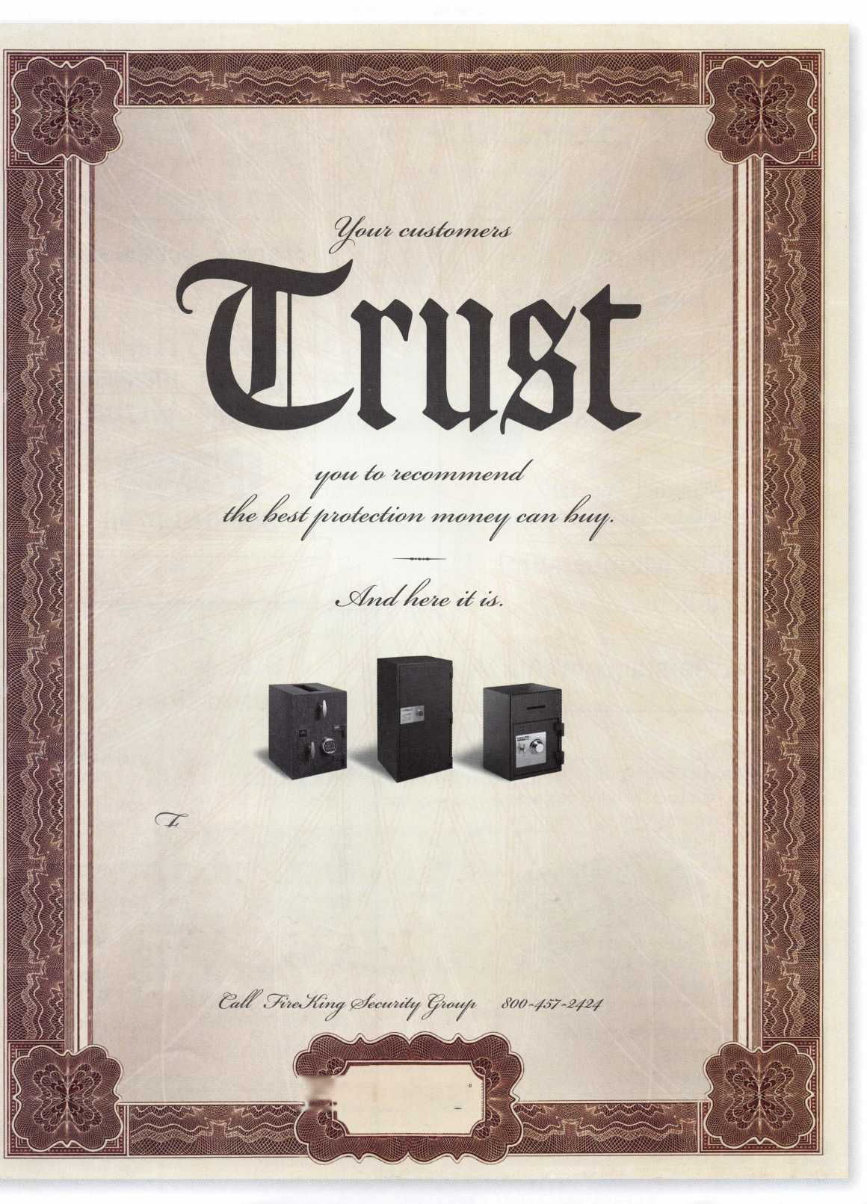

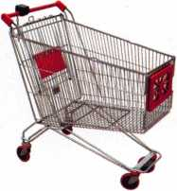
keynotes
Buyer's
Marketplace
\
You need it When?
How about now!? :-)
ClearS tar HI
^{§e}«orkL
Another Special
Value-added Benefit to your
ALOA Membership!
Cl irk hrrr
www.clearstar.com / ALOA
/
/
Accept Credit Cards!
In your Locksmithing Business,
Storefronts/Offices/Homebased
Businesses
**No application fees**
**No Monthly Minimum**
**No Lease Requirements**
**Onsite wireless terminals available**
RETRIEVER PAYMENT
SYSTEMS
888-549-6424
IN-STOCK...MORE SAFES
FREE Freight Program
(30 States)
AMSEC FireKing
Gaidaii hayman
MEILINK yiCTOR.
TURn 10
WHOLESALE SERVICE
800-848-9790
New! Keedex Stainless Steel Armored Door Loops
AVAILABLE FROM YOUR KEEDEX DISTRIBUTOR
ALL
STAINLESS STEEL
DESIGN
FLEXIBLE STAINLESS
STEEL CONDUIT
STAINLESS STEEL
END PIECES
STAINLESS STEEL
MOUNTING SCREWS
COSTS NO MORE
THAN MOST DOOR
LOOPS THAT HAVE
PLASTIC END PIECES
MADE IN U.S.A.
"Ideas That Work”
Call or write today
for yourfree catalog!
Keedex, Inc.
12931 Shackelford Lane
Garden Grove, CA 92841
714-636-5657 • Fax: 714-636-5680
e-mail: info@keedex.com
www.keedex.com
Keynotes • January 2006
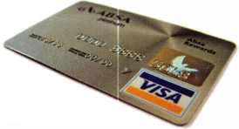
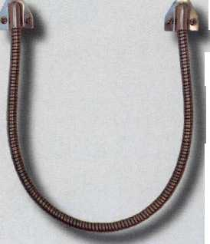
a Few
of Our Titles...
Learn About Basic Electricity 29.95
Spacing and Depths, vol 1 19.95
Spacing and Depths, vol 2 19.95
Filing for Dollars 29.95
Antique Padlocks 29.95
VATS Made Simple (Revised) 29.95
Guide to Transponders 79.00
2000 Transponder Update 45.00
Bread & Butter 85.00
Locks and Lockmakers of America 19.95
Learn About Electronic Locking Devices 29.95
The Best of Locksmithing, vol 1 19.95
Logical Lock Diagnostics 29.99
How to Pick Lever Locks 19.95
Fundamentals of Master Keying 55.00
Guide to Electronic Locksmithing 39.95
Security Solutions Locksmith Marketing Program 89.95
The Ultimate Techtips Collection 39.95
PRP Resource Guide 25.00
Locksmithing from Apprentice
to Master 27.00
Wafer Lock Reading 19.95
Door Lock Encyclopedia 39.95
Lock Repair Manual 14.95
Interchangeable Core Cylinders 34.95
Picking & Impressioning 45.00
The Lure of the Lock 29.95
High Security Safes, vol 1 175.00
High Security Safes, vol 2 175.00
Safeman's Guide, vol 13 9.95
Safe Deposit Depth and Space Manual 99.00
Safe Technician's Reference Manual 155.00
Gun Safes 1 10.00
Modern Safe Opening 59.95
Dave McOmie on Vault Doors, vol 1, Bank Vaults 1 10.00
Dave McOmie on Vault Doors, vol 2, Fire and Plate Vaults 1 1 0.00
Modern Safe Locks 95.00
Drilling Safes 95.00
Safe Deposit Box Service 39.95
Foreign Car Impressioning Book 29.95
Impressioning Ford and GM Side Bar Locks 29.95
Automotive Lock Servicing Update #1: GM 10-Cut Locks 29.95
Automotive Lock Servicing Update #2: GM 10-Cut Locks 29.95
Automotive Lock Servicing Update #3: GM 8-Cut Locks 29.95
GM Locks: Perfect for the Beginning Locksmith! 29.95
Ford Locks: Pin Tumbler and Ten-Cut Systems 29.95
Chrysler Pin Tumbler Locks 29.95
Chrysler Double-Bitted Locks 29.95
Toyota Split-Tumbler Locks 29.95
Basic Door Panel Servicing 29.95
Advanced Door Panel Servicing 29.95
Motorcycles on CD 99.00
The Guide to Motorcycles 99.00
Japanese High Security Auto Servicing 29.95
Revised GM Steering Column Course 1 15.00
Foreign & Domestic Auto Service 69.95
Auto Lock Service 14.95
The Sieveking Auto Key Guide & Illustrated Cross Reference 27.00
Servicing Interchangeable Cores—Sargent 25.00
Servicing interchangeable Cores—Arrow, Best,
Eagle, Falcon, and Lockwood 25.00
The Ultimate CCTV Program on CD Rom 595.00
Visit the new-and-improved ALOA Store to view more available titles.
Place your order online or by phone today!
www.aloa.org • (214) 819-9733* Please allow 3-4 weeks for delivery.
The Master Locksmiths
Association Of New Jersey
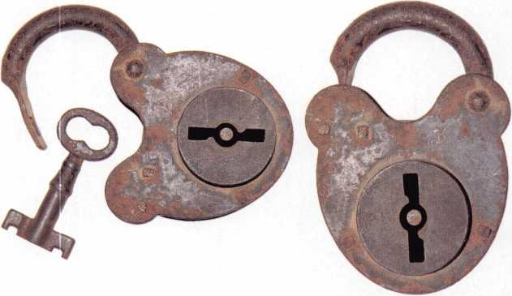
2006
East Coast Regional
Lock & Security Show
(Classes, Trade Show, and Banquet)
March 16th thru March 19th
Crowne Plaza Meadowlands Hotel
2 Harmon Drive
Secaucus, NJ 07094
For more information:
P.O. Box 2441
Morristown, NJ 07962-2441
Fax 973-538-1588 or visit www.MLANJ.org

Alberto, 11 years Machine Operator
CURITY PRODUCTS
Raymond, 4 years Accounting
Shirley, 23 years Lock Assembly
ervice
l We represent the 500 employees of CompX Security Products.
Hardworking. Reliable. Dedicated.
And it shows in the products we make.
Is it any surprise that, year after year, you the locksmith community, choose to partner with us?
Made in America does matter to you, and it matters to us. Through our four US facilities, we will continue to provide you with the high quality products you have come to expect from CompX Security Products.
GarrflC
Com®C
Cbm/X
WQC
NATIONAL
FORT
TIMBERLINE
CHICAGO

* •LKllJpLa
NGS XL CAN
Locksmith 8008LXLC
IS XL CAN Locksmith Kit 8008LXLC
NGS XL Tester and Locksmith VIM NGS XL CAN VIM
1996-Current Model Year Ford Transponder PATS Reprogramming Software
of Software

- FREE
- 81204 - CAN Vehicle Interface Cable
- 81205 - CAN Power Cable
- 800N - OBDII/EEC-V Cable
- HI 05-00100 - Central Security Module Cable
- NGS/Locksmith/PATS Instruction Manual
- Key Blank/System Quick Reference Card
- Transponder Marketing Support Pack
- Blo-molded Carrying Case
- 13 Month Warranty
8008LXLC
CAN VII
81201L
js-Jl (s k
m iH* In
NGS CAN VIM Kit 81201L
81201L
© 2005 Hickok Inc. Made and Printc
Mazda Transp
The most reliable unit available for transponder key programming and PATS system diagnostics on ALL Ford Lincoln/Mercury and Mazda* vehicles.
CAN
CAN VIM
Vehicle Interface Module
CAN Vehicle Interface Module analfcJ * Model Software Update now aSailaol-
TOLL FREEtechsupport
800/342S080
Ford built Mazda vehicles with the PATS system
